**[Project name here]**

**Final Report**

**[Team member names]**

**[Student 1 name]**

**[Student 2 name]**

**[Student 3 name]**

**2020**

[Insert NAU or Team Logo as watermark or include a photo of the team or project]

**Project Sponsor:**

**Faculty Advisor:**

**Sponsor Mentor:** [Note: if any of these categories are the same person, delete the repeats]

**Instructor:**

# DISCLAIMER

This report was prepared by students as part of a university course requirement. While considerable effort has been put into the project, it is not the work of licensed engineers and has not undergone the extensive verification that is common in the profession. The information, data, conclusions, and content of this report should not be relied on or utilized without thorough, independent testing and verification. University faculty members may have been associated with this project as advisors, sponsors, or course instructors, but as such they are not responsible for the accuracy of results or conclusions.

# EXECUTIVE SUMMARY

This project is to design a device which can clean the traffic signs without interrupting the traffic flow and it must contain failsafe to protect the drone. This project interest the sponsor because of the fact that there is no such device available in the market for this purpose and it is necessary to invent such device which clean the sign boards without interfering the traffic and this thing interest the sponsor to work on. This project will be beneficial for the sponsor as sponsor can utilize the design for commercial purpose and the stakeholders like drivers, motorists, and public who travel on highways can travel safely and read the sign boards easily, it will help them in many ways during the travelling. This project is important as it will be beneficial for the public and will keep them safe.

The designing of the project has done from the research, and then generated the concepts. From the concepts the final concept has selected using the Pugh Chart and Decision matrix. Pugh chart has analyzed the concepts against each customer requirement while the decision matrix has analyzed the concepts against engineering requirements. The final design selected was drone flying with the hose. The reason for selecting is that, this design is fulfilling all the project requirements and after that each engineering requirement has calculated for the design and found that each engineering requirement is fulfilling by this design.

The CAD model has developed for the design including the CAD package in which the assembled design has shown as well as the exploded view has shown as well. the design includes a drone with the 10 propellers over it and the propellers will connect with the motors of 6mm that will produce the thrust of 200 N at least, and this thrust can lift the weight of 82 lb. while the total weight of device including the hose is 54 lb. so the thrust producing from this design can easily lift the drone and the hose attach to it. The hose is attaching with the reel at the ground and this reel can rotate with the speed of more than 25 rpm using the motor of 2600 rpm hence the failsafe present in the design can roll over the drone earlier then the gravity and hence the device can land safely. Another thing added in the design is two wheels present at the front of drone, that will help the drone in moving from one place to another place and also it will help the drone in landing safely even in the failsafe situation. The nozzles present at the front of drone will throw the water with high pressure so that water can easily splash on the sign board and using of soft fabric brush, the sign board will clean and the brushes will absorb the water as well.

In the manufacturing and assembly, the DFMA has performed on the design and from the DFMA some improvements have made in the design which reduces the manufacturing cost of design and also reduces the assembly time and hence the overall time and cost both will save through the redesigning of device. All the testing procedures have defined as well to help the client in understanding the project and verifying the engineering requirements.

In the future, design can further improve by adding the sensors and camera so that it will become an automatic drone and will clean the board without the intervention of any human being.

The project has completed with all the rules specified in the team charter and the time management has played a major in success. Along with the ground rules, the coping strategies worked well during the project.

# ACKNOWLEDGEMENT

The team would like to acknowledge the efforts made by instructor **Dr. Sarah Oman** and client **Dr. Hesam Moghaddam**, without their help it was not possible for the team to do this project and we would like to thanks NAU and ME department for giving us a chance to work on such a creative and unique project.

Table of Contents

DISCLAIMER 2

1 BACKGROUND 6

1.1 Introduction 6

1.2 Project Description 6

1.3 Original System 6

2 REQUIREMENTS 7

2.1 Customer Requirements (CRs) 7

2.2 Engineering Requirements (ERs) 8

2.3 Functional Decomposition 9

2.3.1 Black Box Model 9

2.3.2 Functional Model 10

2.4 House of Quality (HoQ) 11

2.4.1 TESTING PROCEDURES (TPs) 12

2.5 Standards, Codes and Regulations 12

3 DESIGN SPACE RESEARCH 14

3.1 Literature Review 14

3.2 State of the Art – Benchmarking 15

3.2.1 System Level State of the Art – Benchmarking 15

3.2.2 Subsystem Level State of the Art Benchmarking 16

4 CONCEPT GENERATION 20

4.1 Full System Concepts 20

4.1.1 Full System Design # 1: Drone with Hose 20

4.1.2 Full System Design # 2: Automatic cleaning Board 21

4.1.3 Full System Design # 3: Rotating Drone with Firefighter setup 21

4.2 Subsystem Concepts 22

4.2.1 Subsystem #1: Propellers 22

4.2.2 Subsystem #2: Motor 24

4.2.3 Subsystem # 3: Microcontrollers 26

5 DESIGNS SELECTED 29

5.1 Design Description 29

5.1.1 Rationale for Design Selection 29

5.2 Implementation Plan 31

6 IMPLMENTATION 34

6.1 Design Changes 34

6.1.1 Design Iteration 1: Change in Water tank discussion 34

6.1.2 Design Iteration 2: Use of Hose 35

6.1.3 Design Iteration 3: Use of Reel 36

6.1.4 Design Iteration 4: Use of Wheels 37

6.1.5 Design Iteration 4: Use of Wheels 37

6.2 Manufacturing and Assembly Plan 38

6.2.1 Manufacturing Plan 38

6.2.2 Assembly Plans 39

7 RISK ANALYSIS AND MITIGATION 44

7.1 Potential Failures Identified 44

7.1.1 Potential Critical Failure 1: Motor winding burning 45

7.1.2 Potential Critical Failure 2: Motor insulation burning 45

7.1.3 Potential Critical Failure 3: Motor wire 45

7.1.4 Potential Critical Failure 4: Arduino Board 45

7.1.5 Potential Critical Failure 5: Arduino Pins 46

7.1.6 Potential Critical Failure 6: Arduino Connection 46

7.1.7 Potential Critical Failure 6: Battery Burning 46

7.1.8 Potential Critical Failure 7: Battery Low Voltage 46

7.1.9 Potential Critical Failure 7: Controller Burning 46

7.1.10 Potential Critical Failure 7: Controller Body Breaking 46

7.2 Risk and Trade-offs Analysis 47

9 LOOKING FORWARD 52

9.1 Future Test Procedures 52

9.1.1 Testing Procedure 1: Flight Time 52

9.1.2 Testing Procedure 2: Height of Flight 52

9.1.3 Testing Procedure 3: Water Tank 53

9.1.4 Testing Procedure 4: Device Weight 54

9.1.4.2 Testing Procedure 4: Resources Required 54

9.1.5 Testing Procedure 5: Reliable in Temperature 54

9.1.6 Testing Procedure 6: Durable 55

9.1.7 Testing Procedure 7: Long Power Backup 56

9.1.8 Testing Procedure 8: Failsafe Rotation Speed 56

9.1.9 Testing Procedure 9: Hose Height 56

9.2 Future Work 57

11 REFERENCES 61

12 APPENDICES 63

12.1 APPENDIX A – DESIGN CALCULATIONS 63

12.2 APPENDIX B: Bill of Material (BOM) 64

12.3 APPENDIX B – FMEA 66

# 1 BACKGROUND

## 1.1 Introduction

Traffic signs play an important role in controlling the traffic and reducing the accidents happens on the highway. Traffic signals indicate which lane need to stop and which traffic lane can go, while traffic signs identify where you are heading, what are the directions to the destination, speed limits define on the signs, instructions given for the prohibited things, miles to reach the destination defines, etc. Traffic signs and signals always hang at high places like poles where it can clearly see from far distance and drivers can reduce the speed for stopping or become alert and drive carefully from that point or follow the instructions define on the signs. Traffic signs always uses sharp color which can clearly see from the long distance. With all these features, traffic signs are quite important for the motorists but as the traffic signs hangs on the highways and roads openly so after sometime sign boards become dirty because of pollution and reading the signs boards become difficult and traffic signs get dim. For that situation it is necessary to clean the sign boards after some interval to make the traffic signs clear for the drivers and keep the highways safe. The contemporary issues define by this project was to clean the traffic signs, this is the first issue, second issue is that big machines use to clean the traffic signs but they block all the traffic on that route and it keep the traveler facing lot of issues, and third issue is that the device to clean the sign board must be safe to use, so safety is another problem define in this project.

This project is to design a device which can clean the traffic signs without interrupting the traffic flow. The main objectives of this project is to keep the traffic continually working, the device is safe to use and it must be failsafe.

This project interest the sponsor because of the fact that there is no such device available in the market for this purpose and it is necessary to invent such device which clean the sign boards without interfering the traffic and this thing interest the sponsor to work on. This project will be beneficial for the sponsor as sponsor can utilize the design for commercial purpose and the stakeholders like drivers, motorists, and public who travel on highways can travel safely and read the sign boards easily, it will help them in many ways during the travelling. This project is important as it will be beneficial for the public and will keep them safe.

## 1.2 Project Description

The project defines as to innovate a device that can clean traffic signs without interrupting the flow of traffic. It has to be operated remotely and it must be reliable and safe to use. It must possess the failsafe condition and the accuracy of the system must be high and it should be eco-friendly as well. During the cleaning water must not fall on the highways.

## 1.3 Original System

Our project is original system and there is no other project developed before when this project has started.

# 2 REQUIREMENTS

The project requires from the team to design a systematic device which can clean the traffic signs on the highways without disturbing the traffic flow. And the device need to be safe to operate and failsafe condition must be present in it. The team will design the device according to the given description of the project. In this chapter, the project description will describe in the form of customer requirements in tabular way, and then engineering requirements devised from the customer requirements. After that QFD will develop to define the relation between CRs and ERs and then identify the most important engineering requirement till the least engineering requirement in a sequence.

## 2.1 Customer Requirements (CRs)

Customer requirements are the project description in a tabular form which contains all the important points of the project define by the client. The purpose of making the customer requirements table is to highlight the main part of the project so that when the project will be ready it can clearly examine through the customer requirement whether the objectives of the project have achieved or not. Another reason to do the customer requirements I to understand the project because sometime the project description is not clear enough to understand the project so customer requirement helps at that time. The customer requirement for this project has been given in the table 1.

Table 1: Customer Requirements

|  |  |
| --- | --- |
| **Customer Requirements** | **Weightage** |
| Do not interrupt the flow of traffic | 9 |
| Failsafe | 8 |
| Collect Water Drops | 7 |
| Clean in short time | 6 |
| Clean without damaging the coating | 5 |
| Safe to Operate | 4 |
| Cost within budget | 3 |
| Durable and Robust Design | 2 |
| Reliable Design | 1 |

Do not interrupt the flow of traffic requirement is meeting the objective as it has asked to develop such design which cannot interrupt the traffic flow so it is directly meting the objective. Failsafe is also the highlighted point in the description so it is meeting the objective as well. Collect water drops, meets the objective as the cleanliness can perform through the water. Short time cleaning meets the objective as to perform the task in quick way according to the objective of project. Clean without damaging the coating meet the objective that state safe to use without causing any trouble, safe to operate the device meet the objective of safe to use, cost within budget is a necessary requirement because budget has given so it must be within that budget and that’s the regular objective of any design project, durable and robust design meet the objective as it is necessary for the design to be long lasting and can easily move from one place to another place so it is meeting the objective of safe to use. Reliable design meets the objective as it need to work all the time in all the conditions.

## 2.2 Engineering Requirements (ERs)

Engineering requirements are the one which developed from the customer requirements and these are the technical details about the project so that the project can develop using these physical values and these physical values can test through different procedures when the product will develop. Table 2 has shown the engineering requirements generated for this project.

Table 2: Engineering Requirements

|  |  |  |  |
| --- | --- | --- | --- |
| **Engineering Requirements** | **Target Values** | **Tolerance** | **Justification** |
| Flight Time | 20 minutes | $$± 5 min$$ | 20 minutes have given, 5 minutes tolerance so that it can work easily in that limit |
| Height of Flight | 100 feet | $$± 10 ft$$ | The normal height required is around 100 feet so tolerance is 10 feet above or below this value |
| Water tank | 20 liters | $$± 3 liter$$ | 20 liter of water is enough to clean boards, and 3 liter of tolerance can easily work for it |
| Device Weight | 30 lb. | $$± 5 lb.$$ | $30 lb$ of device is enough to lift up and $5 lb$ of tolerance to bear the extra load |
| Reliable in temperature | -10C to 40C | $$± 5 C$$ | High range of temperature variation can wear in this range with tolerance of 5 degrees at each point |
| Durable | 2200 MPa | $$± 200 MPa$$ | Bear the shear stress of 2200 MPa to show durability, 2200 MPA is high value so tolerance range is high as 200. |
| Long Power Backup | 30 Mins | $$±5 min$$ | Power require to run the drone and reel must be 30 minutes while the tolerance is 5 minutes |
| Failsafe rotation speed | 25 rpm | $$±5 rpm$$ | The rotation of reel must 25 rpm with the tolerance of 5 rpm. |
| Hose Height | 65 ft | $$± 5 ft$$ | Hose will provide the height of 65 feet with the tolerance of 5 feet. |

Flight time is the time to keep the device in the air and that is necessary for the device because it takes around 10 to 15 minutes to clean a board so the range of 20 minutes flying is enough for cleaning. Height of flight is defining the height that will take off by the system and the product will fly above the defined height and if the board is lower than the 15 feet, it will not clean through this system.

Water tank carrier is basically carrying capacity of the device for the water, and this would be 3 liters which is enough to clean the boards.

Device weight is basically the weight of the device that will carry by the device itself during the flying and the weight is 30 lb. maximum so it can easily lift up in the air and fly.

Reliable in temperature means the device can withstand again harsh temperature either in cold season when temperature goes below 0 degrees or in summer season when temperature goes above 30 degrees. The device must be reliable in such a range of temperature.

Durable means the device must be strong and for this purpose it should have the shear stress of 2200 MPa so that it will not easily break in any condition. The power backup means the power need to supply to the drone as the power is providing from the external source so the time here means the source can continuously provide power without any interruption for minimum of 30 minutes, so that the drone can clean the sign board. Failsafe rotation speed is the rotation speed of reel with which it will retract the drone and save it from falling on the ground due to gravity in case the drone starts malfunctioning and this speed has to be at least 25 rpm. Hose is the component attaching between drone and reel and the height of hose must be 65 feet long so that the drone can easily approach to the sign board.

## 2.3 Functional Decomposition

The project is to clean the traffic signs boards, and it need not to interrupt the flow of traffic as well so in that situation the functional operation of this project will consist of controller which control the main product, that product will reach near to the sign board and it will fly up in the air to clean the board and then will return to the starting point. The cleaning function will consist of a wiper that will dip into the water and scroll that wiper over the sign board to make it clean without putting the water on the ground surface. This was the main functionality of this project, while the functional decomposition for any project consists of two types, one is the black box, and second is the functional model. The black box defines the inputs and outputs of the system without interfering inside the system, and functional model describe the complete process of the input to reach to the output. In the functional model, all the subsystem defines together.

### 2.3.1 Black Box Model

The black box model is basically a model which defines only the inputs and outputs of the system and it has nothing to do with the internal functionality of the system and that is why the name has given to it as the back box. Because what is inside the box is of no interest in black box model, it only sees what we will provide to the system and what we will get from the system. The inputs and outputs consist of material input, energy input and signal input and vice versa for the output. The black box model has shown below

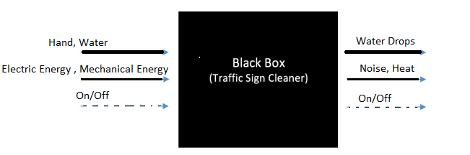

Figure 2: Black Box Model

In the above black box model, human hand and water are the materials uses as the input, hand to control the controller and water to use for cleaning, while for the energy, electrical energy and mechanical energy are using to perform the action, and the signal of the device as the input is either on or off. In the same way, output is showing that the material is water drops while cleaning, in the energy noise and heat will release, and signal is either on or off. It has helped the team in understand the project basic functionality, as through this model it is clear that we will use a controller for performing the task, some water drops will fall down on the ground as the output along with the clean sign board.

### 2.3.2 Functional Model

The functional model describes the complete functionality of the system which can expect after the product will implement. In the functional model all the subsystems will define for the project. The functional model has shown below in the figure.

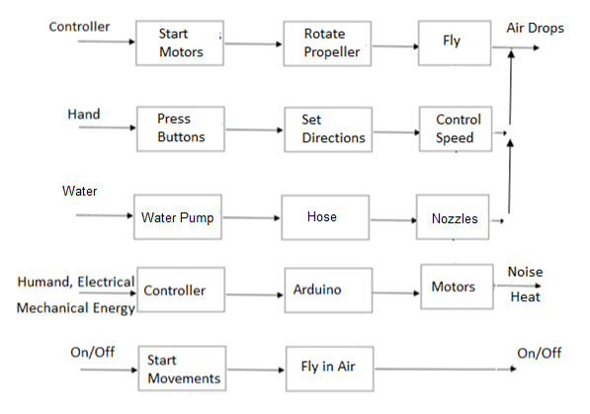

Figure 3: Functional Model

The above functional model contains the subsystems like

* Motors
* Propellers
* Arduino
* Controller
* Water Pump

From this functional model it is easy to understand what will be the functionality of device what we will going to implement. As the complete process has described from starting the motor till the cleaning so this clears the understanding of project.

## 2.4 House of Quality (HoQ)

House of Quality is a chart which describe the relationship between the customer requirements and engineering requirements through a matrix. It is a matrix form, where top side of matrix contains the engineering requirements, left column contains the customer requirements and relating each customer requirement with the engineering requirement and fil their corresponding box with the value that shows the dependency, the dependency can be high and large number will put in that else leave the box. In this way the matrix form and then calculate the absolute importance from the matrix using the weightage values and then relative technical importance for each engineering requirement. In this way the engineering requirement can enlist from the top priority to the least priority. Following figure has shown the House of Quality

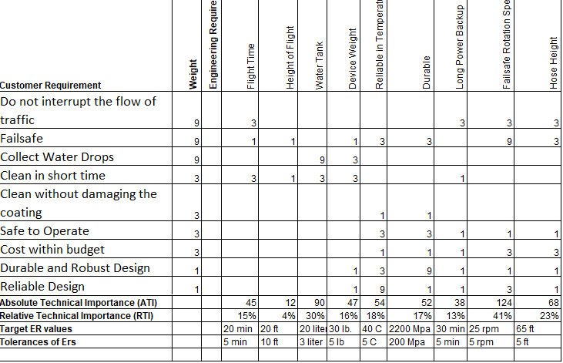

Figure 4: House of Quality (HoQ)

Results of HoQ has shown that the most important engineering requirement is failsafe because it will provide the safety to the device, and the second most important is water tank connecting with the reel and placed on the ground to provide the water and so on.

## 2.4.1 TESTING PROCEDURES (TPs)

In this section the testing procedures have described that will test each engineering requirement and see if the engineering requirement has fulfilled or not. The complete details will provide for each testing procedure against each engineering requirement.

For the flight time it can be done by simply using timer, fly the drone in the air, note the time and the timer is available in the mobile.

For height of flight, it need barometer to install on the device and determine the altitude from the barometer, while the barometer available in the mechanical lab. It can also be done using the GPS which can install on the device and determine the height from it.

For measuring the water tank capacity, either use the feet scale and determine the volume of the water tank or directly test it by putting 20 liters of water in it and see if it can store 20 liters or not. This can be done in the open ground. Feet scale is available in mechanical lab as well.

For measuring the weight, take the weight machine from the mechanical lab, place the drone on it and record the measurements.

For the testing of reliability, a controlled temperature room need to select like available in chemical labs, where the device will place under both highest temperature and lowest temperatures and will operate the device under all types of temperatures to make sure the reliability of product.

For the durability test, stress applying machine is available in the mechanical lab, so use that machine and apply the stress to the pipes of drone and examine the response of pipe.

For long power backup even though it does not need to examine as it is connecting from the outer source but still if want to test then use the mobile timer and turn on the supply and record the consistent supplying time.

Failsafe rotation speed is important to test because if the drone will fall down, the failsafe engine rotates so fast that drone will not hit the ground because of gravity. To determine the motor rotation speed, use the tachometer available in the mechanical lab which counts the rotations of a motor.

And for testing the hose height, use the meter scale in the civil lab and measure the length of hose.

## 2.5 Standards, Codes and Regulations

The Standards, Codes, and Regulation that applied

A list of standards used in the project has given below while the complete details have provided in the following table.

* American Society of Testing and Materials (ASTM)
* Institute of Electrical and Electronics Engineers (IEEE)
* American Society of Mechanical Engineers (ASME)
* Aluminum Association (AA)
* American Gear Manufacturers Associations (AGMA)
* American Welding Society (AWS)

These standards have described below in the table

Table 3: Standards applied to the project

|  |  |  |
| --- | --- | --- |
| **Standard Number or Code** | **Title of Standard** | **How it applies to Project** |
| ASTM | American Society of Testing and Materials | It is applying for the testing of materials that will use in the project to confirm that they will be reliable to use |
| IEEE | Institute of Electrical and Electronics Engineers | All the research in the project has conducted on the basis of IEEE and all the electrical components will consist of IEEE standards for safe and reliable use |
| ASME | American Society of Mechanical Engineers | The mechanical design and mechanical parts will follow ASME like motors to have reliable and safe products. |
| AA | Aluminum Association | For the reliable use of Aluminum if we use in the project structure |
| AGMA | American Gear Manufacturing Associations | The manufacturing of product will follow this standard for the safety of both human and prepare the safe product to use |
| AWS | American Welding Society | Welding may use in the project for joining the structural parts so the welding will perform on the basis of AWS, like will wear the safety products to do the welding. |

# 3 DESIGN SPACE RESEARCH

As the design project always starts with research and find the similar projects and existing projects. And then see what other people have done in this field, like search for the published article and read different designs to understand how the project can implement and which are the necessary functionalities that need to build in the project. There is a literature review which shows the other sources related to the project and describe each source with little summary. And other thing is state of the art or benchmarking, this is showing the existing the designs related the project. In this section, literature review will present and then benchmarking will present, after that existing designs will present for the full system and then existing designs will present for the subsystem of the project.

## 3.1 Literature Review

The literature review has done for the purpose of finding old work done in the field of signal board cleaning. The research has done to find different papers related to the subsystems of the project. The papers usually found for the research were published in IEEE. As a paper stated that windshield wipers assume a key job during unfriendly climate conditions by cleaning the downpour ceaselessly over the windshield territory and gives an unmistakable vision to the driver. The conventional framework anyway requires driver's steady consideration for controlling the cleaning speed physically [4]. Right now, control frameworks are concentrated consequently actualizing different computational devices like fluffy rationale control, neural system control and versatile neuro fluffy derivation framework (ANFIS) control utilizing MATLAB. An Intelligence based control approach is introduced so the windshield wipers can be computerized all the more successfully dependent on the control rationale calculations. It presents a novel based investigation of control calculation by actualizing the above MATLAB apparatuses and their aftereffects of each control calculation fluffy rationale, neural system and versatile neuro-fluffy deduction framework (ANFIS) were considered and contrasted with comprehend the best framework. In the same way another research has found talked automatons are as of late accepting a developing consideration in both common and military divisions. In spite of their great highlights, for example, high mobility, wide assortment of utilization, and ease; battery-controlled automatons are as yet restricted as far as continuance. They can't perform long flights and determined missions. This paper proposes then an audit-based conversation of the arrangements tending to this issue, including swapping laser-pillar inflight energizing and tying. Half and half force supply framework is likewise an answer of decision [5]. Consolidating battery with various sources, for example, power device, sun-oriented cells, and supercapacitor permits the framework to profit by sources points of interest and spread their confinements. Right now, paper gives a relative and basic investigation of various force supply models, in this way encouraging the exchange off in the decision of the reasonable automaton power supply framework. Experiences and suggestions for future research are likewise given. Similarly, a structure strategy and investigation instrument of a UAV propeller dependent on Blade Element Momentum Theory (BEMT) for low-Reynolds number stream is introduced [6]. BEMT is finished with 3D harmony execution, a post-slow down model and whirl speed contemplations to improve the exactness of the outcomes. An open-source code, JBlade, in light of BEMT is utilized to get execution bends in off-structure cases for a given propeller. At long last, the outcomes are examined for a UAV Hirrus propeller. This procedure can be utilized effectively in the starter configuration period of a UAV propeller, whose information would then be able to be utilized as contribution to an advancement strategy [8]. This paper investigates the working guideline and uses of an Arduino board. This additionally investigates on how it very well may be utilized as an apparatus for study and research works. Arduino board can give a fast device being developed of VLSI test seat particularly of sensors. Principle points of interest are quick preparing and simple interface [9]. Today, with expanding number of individuals utilizing open source programming and equipment gadgets for a long time, innovation is framing another measurement by making confounded things look simpler and intriguing. These open sources give free or for all intents and purposes low costs, exceptionally dependable and reasonable innovation. This paper gives a look at kind of Arduino sheets, working standards, programming execution and their applications [10].

## 3.2 State of the Art – Benchmarking

The project is to implement a system which can clean the traffic signs, so the benchmarking has done by search over the internet and find the sources which are relevant to the project. From the search different existing designs have found, but there are not much existing designs available for this concept so the existing design found were then summarized in the next section. The concept of this project is kind of new and there was not much work done in this field therefore it was even difficult to find the existing designs for the project.

### 3.2.1 System Level State of the Art – Benchmarking

For this project existing designs have found which were using for cleaning the sign boards. As state earlier there was not much work done in this field so finding the existing design for the system level was quite difficult but it has found and presented below.

#### 3.2.1.1 Existing Design # 1: VISIONCLEAN

This is an existing design which uses a big truck over which watery jet brushes uses to clean the sign boards, this is quite big truck and it can clean the traffic signs by interrupting the traffic flow. It is bigger in size and cleaning the big sign board is easy through it but for small signs it is difficult to clean with it [11]. Also, it consumes lot of fuel to clean the sign boards.

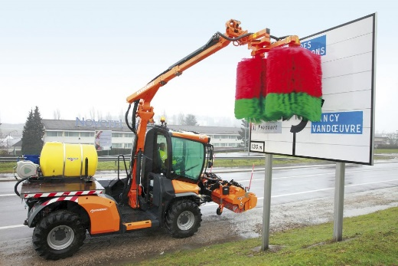

Figure 4: VISIONCLEAN

#### 3.2.1.2 Existing Design # 2: Manual Cleaning

Another way to clean the traffic signs is through the manual system, in which human do it directly using the brush [12]. This is one of the old ways and it commonly uses to clean the boards. This is Important that cleaning the signs with humans is easy rather than using the vision clean truck method. An example of manual cleaning has shown below

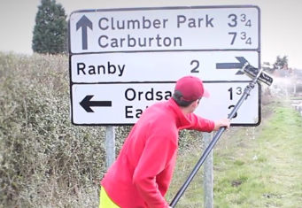

Figure 5: Manual clearing by MNA

#### 3.2.1.3 Existing Design # 3: Solar Board Cleaning

Another exiting design found for cleaning the boards, is an automatic cleaning board but it is not using in cleaning the signs, while it can use for cleaning the sign boards, it sticks over the board using the channels and then automatically move from one position to the other using the slider to clean the board as it has shown in the following figure [13]

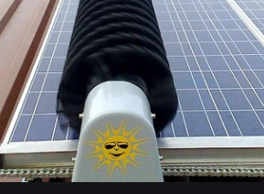

Figure 6: Automatic Board Cleaning

### 3.2.2 Subsystem Level State of the Art Benchmarking

As like the top-level system benchmarking has done, there are some subsystems exists in the project which are useful and important for the project. There are some existing design present for each subsystem and each subsystem existing design has found using the research.

#### 3.2.2.1 Subsystem # 1: Propellers

Propellers uses for lifting the jet, drones, helicopter in the air. In this project propellers will use to lift the device up in the air and then fly towards the sign board and clean. There are some existing designs of propellers which are presenting below

##### 3.2.2.1.1 Existing Design # 1: Plastic Propeller

Plastic propellers have already developed and available, these are light weight and sharp propeller and it commonly uses in the drones which is light weight body to move up in the air. And this existing design can use in the project as well [14].

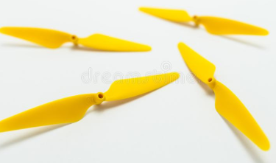

Figure 7: Plastic Propellers

##### 3.2.2.1.2 Existing Deign # 2: Aluminum Propellers

Another existing design of propeller is aluminum propeller which is available, these are sharp and heavy propellers comparing to the plastic propellers while these propellers uses in the water specifically to move the boats [15]. These propellers can also use in our project.

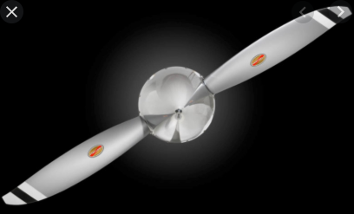

Figure 8: Aluminum Propellers

##### 3.2.2.1.3 Existing Design # 3: Carbon Fiber Propellers

These are the light weight and strong propellers now a days using all type of flying items including drones and small helicopters. These propellers are strong but light weight which make them quite useful and these propellers are the best option to use in this project as well [16].

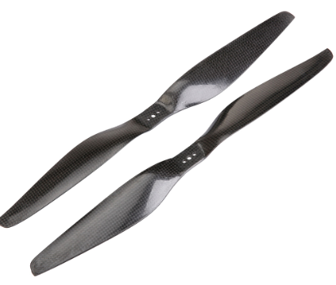

Figure 9: Carbon Fiber Propellers

#### 3.2.2.2 Subsystem # 2: Motors

Motor is one of the most important aspect in this project because motors will use to fly the device, and it will use to move the wipers and it will use to throw the water on the sign board and clean the board. So almost each part of the device contains the motors.

##### 3.2.2.2.1 Existing Design # 1: DC Motor

A simple DC motor is an existing design developed already and it has been using widely in the projects at small level because of their small and compact size. These motors can easily work on the batteries and provide long battery backup because of low power consumption. These are useful for this project as well [17].

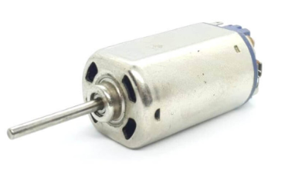

Figure 10: DC Motor

##### 3.2.2.2.2 Existing Design # 2: Stepper Motor

It is also a DC motor but it uses te angles and steps to move in both directions which make it useful where the slow motion and angle motion required from the motor [18].

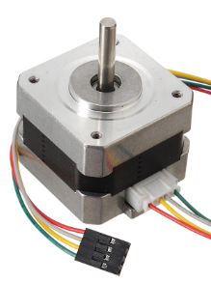

Figure 11: Stepper Motor

##### 3.2.2.2.3 Existing Design # 3: Servo Motor

It is another type of motor which works on DC but it is powerful and high torque generated motors and these motors are widely using in the robotics now and can use in this project as well [19].

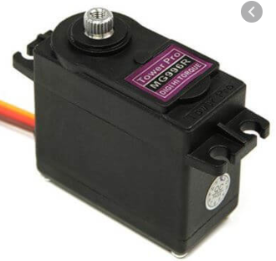

Figure 12: Servo Motor

#### 3.2.2.3 Subsystem # 3: Microcontroller

This is another subsystem in this project and it will use to control the complete project. Microcontroller will take the instructions from user and will act accordingly. All the motors will control through the microcontroller so it will be main part of this project.

##### 3.2.2.3.1 Existing Design #1: Arduino Controller

Arduino is a package which has each part connected over a single chip and this can use in the project as a main controller and no need to connect another controller or driver circuits to make it working. This whole chip can code through C language or Arduino built in language available online [20].

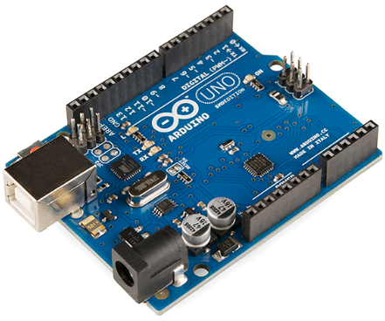

Figure 13: Arduino Controller

##### 3.2.2.3.2 Existing Design #2: Raspberry Pi Controller

This is another available controller to use similar to the Arduino with other features like built in double USB ports, fully operational and it can easy to mount in small products without doing lot of efforts to resolve the problem [21]. This can also use in this project.

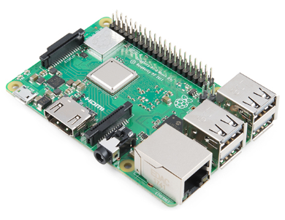

Figure 14: Raspberry Pi Controller

##### 3.2.2.3.3 Existing Design #3: BeagleBoard

This is another existing design for the controller and it is a low power consumption board in which the device will operate using the low power and it is also an open source module to use in this project [22].

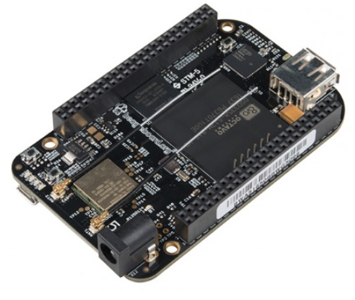

Figure 15: BeagleBoard

# 4 CONCEPT GENERATION

In this section the concept generated for the project will present, for the complete design as well as for the subsystems. From these fully generated designs the final design will select in the next section using different criteria and methods.

## 4.1 Full System Concepts

The full system concepts are the concepts of complete project and these concepts have generated using the head storming. The ideas generated here will use in the next section for the final selection.

### 4.1.1 Full System Design # 1: Drone with Hose

This design consists of a drone with the hanging hose to hang the water bucket and it will control through the RC remote and it will fly in the air to reach to the location and clean the sign board using the front brush rollers of some soft fabric. These brush rollers will clean the sign board and absorb the water from the board. The number of propellers using in the design are 10, and there is a hose attaching with the drone and then it is connecting with the reel placed on the ground hence the reel and hose are providing the failsafe to the drone. The central box contains the control system like Arduino, and it is getting power from the external source through the hose pipe. The hose pipe is then forwarding to the water tank where it will get the water from the tank and it will push the water up to the drone through the water pump.

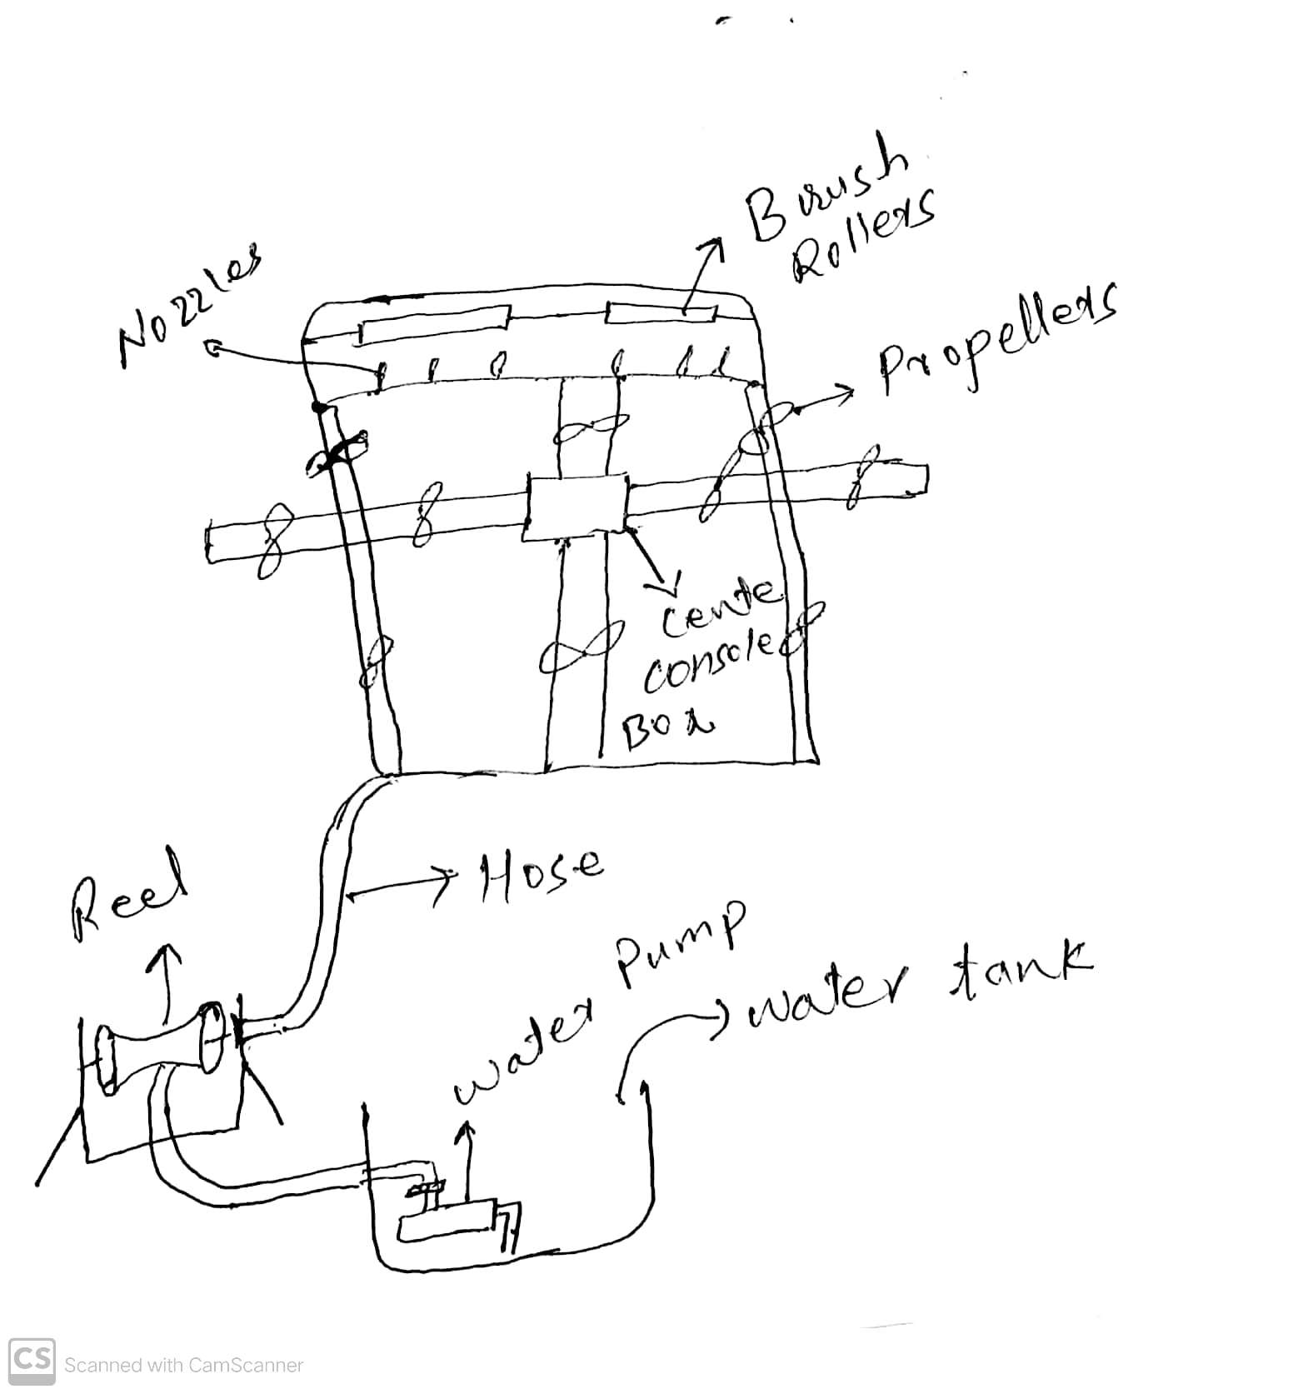

Figure 16: Drone with Hose

Pros:

* No traffic flow disturbs
* Easy approach
* Safe to use
* No water will drop out

Cons

* Difficult to move in the storms
* Costlier

### 4.1.2 Full System Design # 2: Automatic cleaning Board

This is a device that need to fit on the sign board and it will automatically move from one end to the other end without taking any help. It will clean the board and then it will remove from the board using the support.

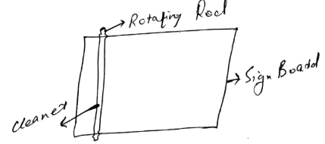

Figure 17: Automatic Cleaning Board

Pros

* Quick service
* Quality cleaning

Cons

* Traffic may disturb in attaching or removing the system

### 4.1.3 Full System Design # 3: Rotating Drone with Firefighter setup

This system is similar to the drone with the automatic control and it has the firefighter setup which throw the water directly to the sign boards from little distance and it will clean the boards.

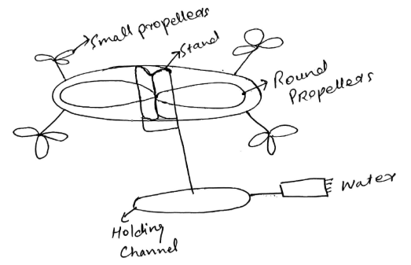

Figure 18: Firefighter setup drone

Pros

* Quick Service
* High performance
* Quality Cleaning

Cons

* Water can split on road when operate not carefully

## 4.2 Subsystem Concepts

In this section subsystem concepts generated for the parts will present and it will use to select the best option that will use in the project. These are the same subsystems defined in the state of art section previously and existing designs have presented for them.

### 4.2.1 Subsystem #1: Propellers

#### 4.2.1.1 Design #1: Two Straight Propellers

In this design the straight propellers have generated, these are two propellers connected from the middle.

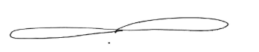

Figure 19: Two straight propellers

Pros

* Sharp
* Light weight

Cons

* Thrust will be less

#### 4.2.1.2 Design #2: Three Propellers

In this design three propellers interlinked from the center

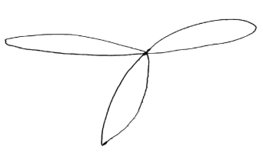

Figure 20: Three propellers

Pros

* High Thrust

Cons

* Heavy weight

#### 4.2.1.3 Design #3: Round Three Propellers

A round circle in which three propellers have connected together to lift the drone up.

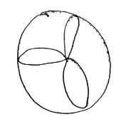

Figure 21: Round three propellers

Pros

* High Thrust

Cons

* Heavy weight
* Not sharp

#### 4.2.1.4 Design # 4: Rim Propellers

The shape of propeller is like the wheel, and it can rotate in the same way to generate the thrust

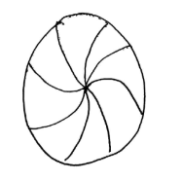

Figure 22: Rim Propellers

Pros

* High trust

Cons

* Heavy weight
* Not sharp

#### 4.2.1.5 Design #5: Single Propeller

A leaf shape propeller to rotate along with the other propeller connects from the same point.

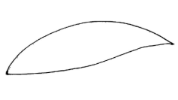

Figure 23: Single Propeller

Pros

* Light weight

Cons

* Small thrust

### 4.2.2 Subsystem #2: Motor

#### 4.2.2.1 Design #1: Square motor

The design is simple a square form in which a rotor is standing at one side of the box for rotation purpose.

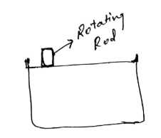

Figure 24: Square motor

Pros

* High speed

Cons

* Heavy in weight

#### 4.2.2.2 Design # 2: Round Motor

It is a round motor in which a rotor has placed at the front side

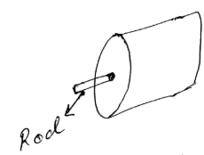

Figure 25: Round Motor

Pros

* Light weight

Cons

* Low speed

#### 4.2.2.3 Design #3: Two rods round motor

Two rods are present in the round motor.

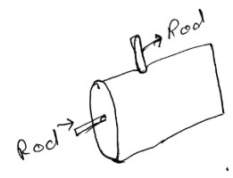

Figure 26: Two rods round motor

Pros

* Double rotation

Cons

* Low speed

#### 4.2.2.4 Design #4: Square Two Rods motor

This is a square motor with two rods on it.

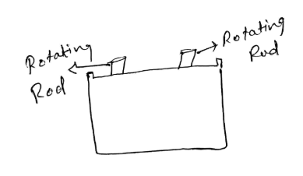

Figure 27: Square Two Rods Motor

Pros

* Double Rotation

Cons

* Low speed
* Heavy weight

#### 4.2.2.5 Design #5: Square box motor

It is a square box shape motor.

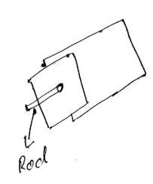

Figure 28: Square box motor

Pros

* High speed

Cons

* Heavy weight

### 4.2.3 Subsystem # 3: Microcontrollers

#### 4.2.3.1 Design #1: Chip controller

It contains only the microchip and it need the drivers separately to run.

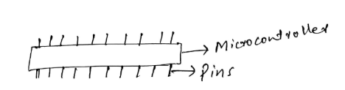

Figure 29: Chip controller

Pros

* High Speed

Cons

* Need drive circuits

#### 4.2.3.2 Design # 2: Double Chip Controller

This controller contains two chips to make the operation fast and it contains built in circuitry.

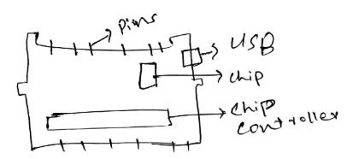

Figure 30: Double Chip controller

Pros

* High speed
* Circuitry available

Cons

* Costly

#### 4.2.3.3 Design # 3: Single Chip Controller

This control has one microchip with all the circuitry install over it.

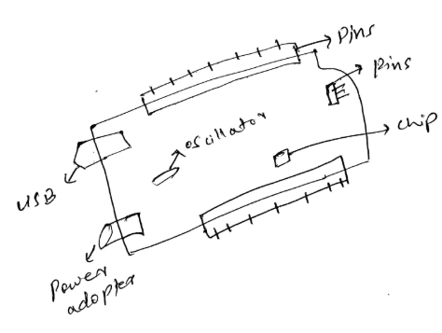

Figure 31: Single Chip controller

Pros

* Economical
* Circuitry available

Cons

* Low speed

#### 4.2.3.4 Design # 4: Two ways controllers

This controller contain the chip connect in two parts which can get separate as well.

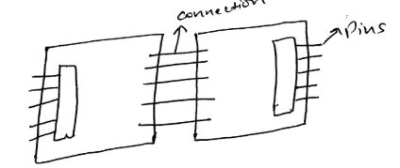

Figure 32: Two Ways Controllers

Pros

* Two Controllers
* Circuitry available

Cons

* Costly

#### 4.2.3.5 Design #5: Simple Chip with circuitry

This controlled contain a chip with USB and power adopter without the microcontroller, it will install the microcontroller over.

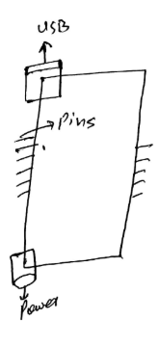

Figure 33: Simple Chip with Circuitry

Pros

* Economical

Cons

* Low Speed
* Chip not available

# 5 DESIGNS SELECTED

In chapter 5, it states that the way to select any design for the design project depends on the criteria which evaluate the generated concepts on equal basis and these types of methods includes Pugh chart, and decision matrix. Through these methods, we can easily evaluate multiple design and then narrow down the result to get the final solution.

## 5.1 Design Description

In order to select the designs using the method, it has devised to use Pugh chart which narrow down the results from top three to top two and then use the decision matrix to select the final design. The top design will evaluate through the back of envelop equations. The criteria for the Pugh chart is customer requirements and the criteria for the decision matrix is engineering requirements.

### 5.1.1 Rationale for Design Selection

The two methods which will use to select the final design have stated below

**Pugh chart**

It is a chart which check each design with the customer requirement and see if the requirement is fulfilling by the design or not, if not then put negative sign, and if yes then put the positive sign. Then adds up the positive and negative signs to see which design got the highest positive signs. In this way the top two design will select.

Table 3: Pugh Chart

|  |  |  |  |  |  |
| --- | --- | --- | --- | --- | --- |
| TRAFIC SIGN CLEANER | Weight | Drone with hose | Firefighters Drone | DATUM | Automatic Board |
| Do not interrupt the flow of traffic | 9 | + | + | D | + |
| Failsafe | 8 | + | - | D | - |
| Collect Water Drops | 7 | + | + | D | + |
| Clean in short time | 6 | + | + | D | + |
| Clean without damaging the coating | 5 | + | + | D | + |
| Safe to Operate | 4 | + | + | D | - |
| Cost within budget | 3 | + | + | D | + |
| Durable and Robust Design | 2 | + | - | D | - |
| Reliable Design | 1 | + | + | D | - |
| Pluses |  | 9 | 7 | - | 5 |
| Minus |  | 0 | 2 | - | 4 |
| Total |  | 9 | 5 | - | -1 |

The top two designs are

1. Drone with hose
2. Firefighter Drone

Now move to the Decision matrix

**Decision Matrix**

It will multiply the weightage with the raw number for each requirement against each design and then will add up the numbers to see the highest marks and that will be the final design.

Table 5: Decision Matrix

|  |  |  |  |  |  |  |  |  |  |  |
| --- | --- | --- | --- | --- | --- | --- | --- | --- | --- | --- |
| Decision Matrix | Flight Time | Height of Flight | Water Tank | Device Weight | Reliable in Temperature | Durable | Long Power Backup | Failsafe Rotation | Hose Height | Total |
| Weight | 9 | 8 | 7 | 6 | 5 | 4 | 3 | 2 | 1 |  |
| Drone with Hose | 6x9 = 54 | 6x8= 48 | 6x7= 42 | 6x6= 36 | 4x5= 20 | 6x4= 24 | 6x3= 18 | 4x2= 8 | 5x1= 5 | 245 |
| Firefighter Drone | 3x9= 27 | 2x8= 16 | 4x7= 28 | 3x6= 18 | 2x5= 10 | 4x4= 16 | 3x3= 9 | 2x2= 4 | 2x1= 2 | 130 |

From the above results it is clear that the best option to use is drone with hose, because of high advantage over the firefighter drone, as firefighter drone has the low capability of carrying the water but in the drone with hose, water tank is present on the ground therefore ample amount of water will available and also the presence of reel will give the failsafe to the drone that is an important requirement to fulfill in this design project therefore, it has decided to select the drone with the hose.

## 5.2 Implementation Plan

The design has decided to implement using the pipe structure because of their strength and the pipe structure will give high strength to the drone as well. Along with that it will use the motors to place under the propellers, and then nozzle will fix with the screws. The controller to use will be Arduino. The remote control will be RC and it will control the drone to move forward, backward, up and down. The hose will fly with the drone in the air and its other end will present on the ground. The hose will make using the flexible pipe to make the device light weight. For the implementation of design, it will design a prototype first for the basic pipe structure. The failsafe will provide by the hose and reel, and the motor to use for the reel engine will be of high speed, enough speed to overcome the gravity effect and rollover the drone to the ground safely. The CAD model for the design has shown below

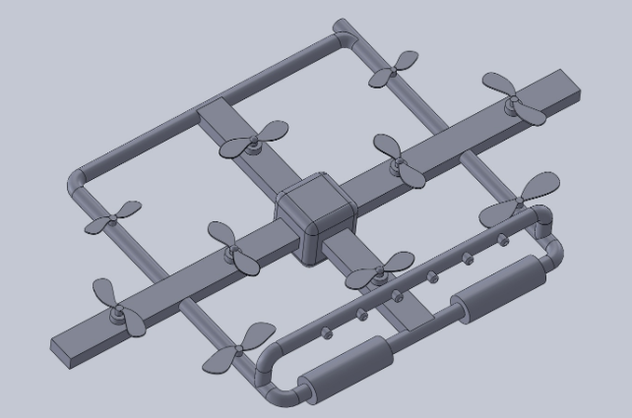

Figure 34: Final CAD Model

The exploded view of the design has shown underneath

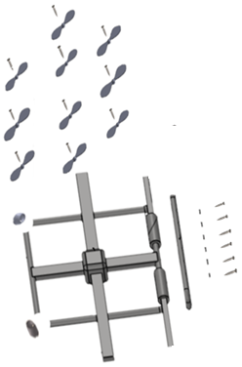

Figure 35: Exploded View with the Assembly

And the basic bill of material developed has shown underneath while the complete bill of material has provided in the appendix as well.

Table 6: Bill of Material

|  |  |  |  |
| --- | --- | --- | --- |
| **Part Name** | **Qty** | **Unit Cost** | **Cost** |
| 6 mm Motor | 10 | $25.07 | $250.72 |
| Steel Sheet | 1 | $38.32 | $38.32 |
| Arduino | 1 | $3.49 | $3.49 |
| Controller | 1 | $27.99 | $27.99 |
| Reel Motor | 1 | $78.28 | $78.28 |
| Hose | 1 | $29.50 | $29.50 |
| Screws | 50 | $0.02 | $1.14 |
| Pipe | 8 | $22.31 | $178.50 |
| Electric Power Wire | 1 | $11.96 | $11.96 |
| Jumper Wires | 4 | $1.00 | $4.00 |
| Wheels | 2 | $1.23 | $2.45 |
| Propeller | 10 | $6.06 | $60.55 |
| Brushes | 2 | $6.10 | $12.20 |
| Nozzles | 5 | $4.02 | $20.10 |
| Reel | 1 | $50.00 | $50.00 |
| Glue | 2 | $1.22 | $2.44 |
| **Total** | | | **$771.64** |
| **Total incl. tax** | | | **$902.82** |

And some basic calculations regarding the design have shown in the appendix as well. In the second semester we will work on the analysis to select the materials, the final design will test, different calculations will perform to see if the design will work and anything need to change in the design will perform as well. The DFMA will perform in the second semester as well to see if the design can reduce with the number of parts and manufacturing cost can reduce or not. All of these things will perform in the next semester. Here is a Gantt chart showing the next semester schedule.

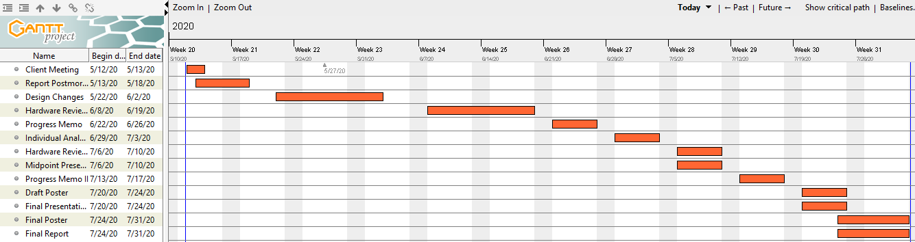

Figure 36: Gantt Chart next semester

# 6 IMPLMENTATION

This is the second semester start, where the implementation of the project has started. The team has started working on the components and perform the analysis for different subsystem to finalize the design and the components. All the design changes are cooperating in this phase as well.

## 6.1 Design Changes

At the start of the project considering the preliminary report and final design selection, the design selected was similar to the one it is now but the problem was about the battery backup and water source.



Figure 37-A: Final CAD Design from previous semester

This design was decided to get the power from the battery and then decided to get the power from outer source but it has not decided at that time how to get the power source connects with the water. Also, the design was considered to have the water bucket along with the drone but later on we have decided to make these changes and now the final design is using the hose to make the connection with the drone and it stand on the ground and there is a reel connected with the hose and there is a water tank connected with the hose as well. And the power wire is also passing by the hose, in this way the drone will get the water supply and electric power and also the failsafe feature.

### 6.1.1 Design Iteration 1: Change in Water tank discussion

The original design before was to have the water tank carrying with the drone and yet it has not designed but just the idea has selected that the bucked or bottle will hold with the drone and it will supply the water to the nozzles for cleaning purpose. The motivation for changing this design is that in this way the device will not get to heavy and surplus water will available. And this water can easily use by the drone for long time. The design of the water tank has shown below

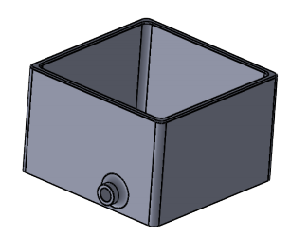

Figure 37: Water Tank

Before that the water tank was using of 3 liters and now the size has increased and the capacity of this water tank is more than 30 liters but the team will keep 20 liters of water in for the use. Hence it is clear that

$$3 Liter>20 Liter$$

So, the above condition is the main purpose why the water tank has designed separately and made this change in old design.

### 6.1.2 Design Iteration 2: Use of Hose

In the capstone 1 design the hose was designed and it was not decided yet how to use the hose but recently it has designed that the hose will use in the form of a straight pipe which is foldable and can increase and decrease the size of it. And the drone is connecting through the hose using flexible pipe. And the reel, water and electricity are passing through the hose and connected with the drone. The design of drone has shown below

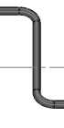

Figure 38: Hose

The above hose has a height of around 65 feet and it will support from the ground and connect the reel with the drone. The motivations for selecting the hose that will attach with the ground are

* It will provide the failsafe to the system
* Water will supply to drone from the outer tank
* Electric power will pass to the drone through the hose

With these three features it has decided to put the hose in the design. And the length of hose has decided to keep at 65 feet with the tolerance of +/- 5 feet.

$$Average Length of Sign Board=50 feet$$

$$Hose Length=65 feet$$

Hence hose can easily reach to the sign board and connect with the drone.

### 6.1.3 Design Iteration 3: Use of Reel

The next thing which has added to the design is reel, this reel is an automatic reel which is connecting with the drone for the fail-safe purpose. In the capstone 1 design it has decided by the team how to provide the failsafe to the system so the reel was not present in that design but now the design has changed and added the reel in it with the automatic function in such a way that when the drone will malfunctioning or stop working, reel will instantly pull over the connection with drone and bring the drone back to the ground. Here is the reel attached with the hose to the drone.

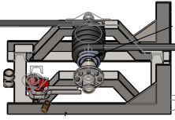

Figure 39: Reel

The reel is working with the motor and the motor has to move with the speed that the drone will not fall because of gravity and it will roll over because of reel.

Consider that the object (drone) is present at the 50 feet.

$$distance=S=50 feet$$

$$distance=S=15.24 m$$

Now we need to find the speed of the object falling freely due to gravity

$$v=\sqrt{2*d*g}$$

$$g=9.81\frac{m}{s^{2}}$$

$$v=\sqrt{2*15.24*9.81}$$

$$v=\sqrt{299.0088}$$

$$v=17.2919\frac{m}{s}$$

So, the speed of the object falling downward because of the gravity at a height of 50 feet is v = 17.2919 m/s.

Now the rotation of motor can define as

$$ω=\frac{v}{r}$$

$$r=radius of motor$$

$$r=0.1 m$$

$$ω=\frac{17.2919}{0.1}$$

$$ω=172.92 rpm$$

Hence the motor needs to rotate with the speed higher than 172.92 rpm to save the drone from falling. Hence the minimum revolution per minute is 20 revolution per minute. And it has stated already in the engineering requirements.

### 6.1.4 Design Iteration 4: Use of Wheels

In the previous design no wheels were added in the design but as some modifications have made into the design so it has decided by the team to put two wheels at the front of design so that the device can easily move on the ground from taking the device from one place to another place. But there is another benefit of using the wheels, and that is the device will safely land to the ground when it will come back from the height, and it will also provide safety to the device while the device will be rescued through the failsafe option. In failsafe situation the drone will not hit hard on the ground because of the presence of wheels. The wheels added to the design have shown below

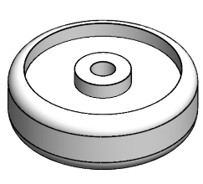

Figure 40: Wheels

After making all these changes into the design following final design has developed

### 6.1.5 Design Iteration 4: Use of Wheels

Another change has decided to make in the design is the material of brush, before that it was decided to make nylon brush that will clean the board but because nylon brushes are not water absorber and in this way the water will fall down to the ground. And hence the project wants the water not be fall down on the surface, after that the team has decided to use the towel fabric cover the brush rollers, there are two benefits of using towel fabric for the brush

1. Towel fabric can absorb the water
2. It is soft and will not cause any damage on the board

With the above two reasons, team has decided to use the towel fabric so that all the water present on the sign board will easily absorb by the fabric brush and no water will fall down on the surface, and second thing is that when this brush will rub on the sign board, it will remove all the dust present on the board and towel fabric will clean the boards in good quality. While the soft stuff nature of towel fabric will not damage any part of the sign board not even the writing stuff present on the board so using the towel fabric is better as compare to the nylon stuff for the cleaning purpose.

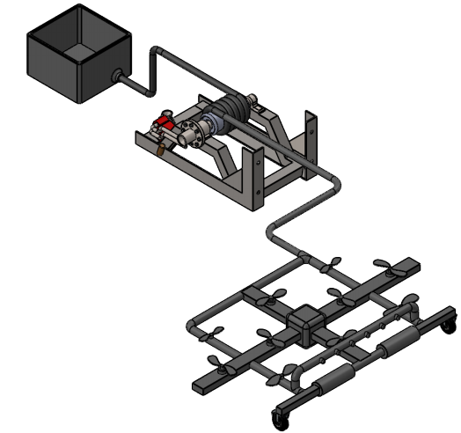

Figure 41: Final Design (After Changes)

In the above design, water tank, automatic reel, hose and wheels can clearly see and these are the things which have added into the design to the design operational and fulfil the client requirements. Now the above design can work easily for cleaning the sign board.

## 6.2 Manufacturing and Assembly Plan

In this section the details will provide regarding the manufacturing plan and assembling the product.

### 6.2.1 Manufacturing Plan

For the manufacturing following step need to follow:

* Take the ABS round pipe lengths and cut them down using the blade. The ABS pipes can easily cut through the blade so cut 4 pieces of 30 inches length. Cut two pieces of pipes having 35 inches length.
* And then take the square pipe and cut that pipe into two pieces, one piece of 40 inches length and second piece of 30 inches length.
* Use the sharp edge blade and mark the points where propellers will install on the square pipe, cut that points through the blade from the upper side only so that rotor can easily come out of the pipe.
* Now mark the round pipes where the propellers will install and remove the upper side through the blade for the rotor and propeller position.
* Take a round pipe length and mark the points where nozzles will install, 6 points will be marked, cut those round points according to the size of nozzles. The pipe structure is ready to make after assembling the pipes. That will describe in the design of assembly section.
* For the hose, take the pipe and measure the length of 65 feet, and cut the hose using the blade.

Following parts will need to purchase:

Table 7: Components and Quantity

|  |  |
| --- | --- |
| **Components** | **Details/Quantity** |
| 6 mm Propeller Motors | 10 |
| Water Tank | 1 |
| Water Pump | 1 |
| Water Pump Nozzle | 1 |
| Arduino UNO R3 | 1 |
| RC Controller | 1 |
| Fabric Brushes | 2 |
| Brush Rollers | 2 |
| Roller Motors | 2 |
| Reel with Motor | 1 |
| Hose | 1 |
| Pipe | 150 feet |
| Electric Power Wire | 100 feet |
| Jumper Wires | 1 Set |
| Wheels | 2 |
| Propeller | 10 |
| Shower nozzle | 6 |
| Glow | 2 Packs |
| Screws | 1 Set |
| Clamps for holding hose connections | 10 |
| Elbows | 6 |
| T-Shaped connector | 1 |
| PVC Tape | 3 |
| Plastic Box | 1 |

After getting the above components, it will then assemble and the process of assembly has described in the design of assembly which is presenting underneath.

### 6.2.2 Assembly Plans

Assembly as done using the following steps:

* Take the pipe pieces and then connect the elbow with two pipes at their both ends through the glow. After joining the elbows, connect the other two pipes in the elbow and make it firm using the glow. So square structure of pipes has assembled. Like the one shown below

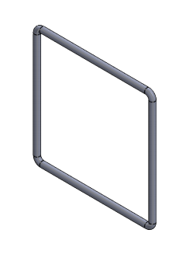

Figure 42: Pipe Outer Structure

* Now in the middle of pipe structure draw a plus sign using the square pipes and join them with round pipes through the glow. The horizontal square pipe makes it large so it goes out of the pipe structure. And in the center of plus sign, place the control box in which Arduino will fix. The box will connect with the square pipes through the glow.
* Now place the motors inside the square pipes, and tight them using the screws. 10 motors need to install at the propeller’s location. After fixing the motors with the screws, connect the propellers with the rotor of motors, one propeller will connect with one motor, hence 10 propellers will connect for the 10 motors. The propellers will fix on the rotor using the screws.
* Now connect the front brush roller with the pipes using the glow, but before installing the front pipe, put the rollers inside the pipe and then fix it.
* The wheels need to connect at the front pipe, and it connects through the long nut and bolts. Place the wheels and then pass the bolts from the middle of the wheels and then cover the nuts with the bolts to tight the wheels.
* Install the nozzles on separate pipe and tight them with the screws and then connect the nozzle pipe with the pipe structure using the glow.

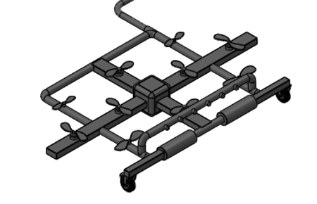

Figure 42: Drone Structure

* Now the structure is ready, connect the motors with the Arduino for motor controller through the jumper wires, also connect the nozzle showers with the Arduino through the jumper wires, and then connect the roller motors with the Arduino through the jumper wires.
* The drone structure has developed, now connect the drone structure with the hose. To connect the hose with the drone a T-shaped connected has used at the back end of drone where it inserted the T- pipe joint into the hose and then clipped the hose tightly.
* Now pass the electric power wire along with the hose and connect it to the Arduino at the center of console.
* Now connect the hose with the reel and power wire with the socket. Wrap the wire around the hose and then tight the hose with the reel. The reel connects with the hose through the joint socket and clipped tightly.
* Pass the hose to the water tank and connect the hose with the water pump present inside the water tank. The hose connects with the water pump through the nozzle. The power wire connects with the water pump to provide electricity to the pump.
* Connect the reel with the motor engine and pass the electric wires to the motor engine for electric supply. The reel is already an assembled component and just need to connect the motor with the reel through the belt.

The complete assembly can understand from the following figure showing the exploded view.

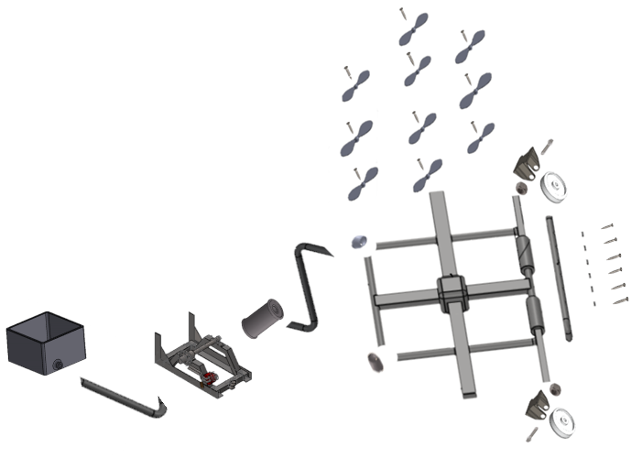

Figure 43: Final Assembly

This assembly will take 120 seconds to setup, and it includes total 56 number of parts. These parts include 20 screws, 2 nut bolts, and 6 elbows as well. After that we have performed the DFMA (Design of manufacturing and Assembly). So, started with the design of assembly. By performing design of assembly, we have removed the screws and use the fixed holes for the propellers and also for the nozzles, while we removed the elbows and connect the pipes directly at the 90 degrees. And replaced the nut bolts with single two side pins to lock the wheels. In this way the number of components has reduced from 56 parts to 32 parts. After performing the DFMA, following modifications have obtained in the design.

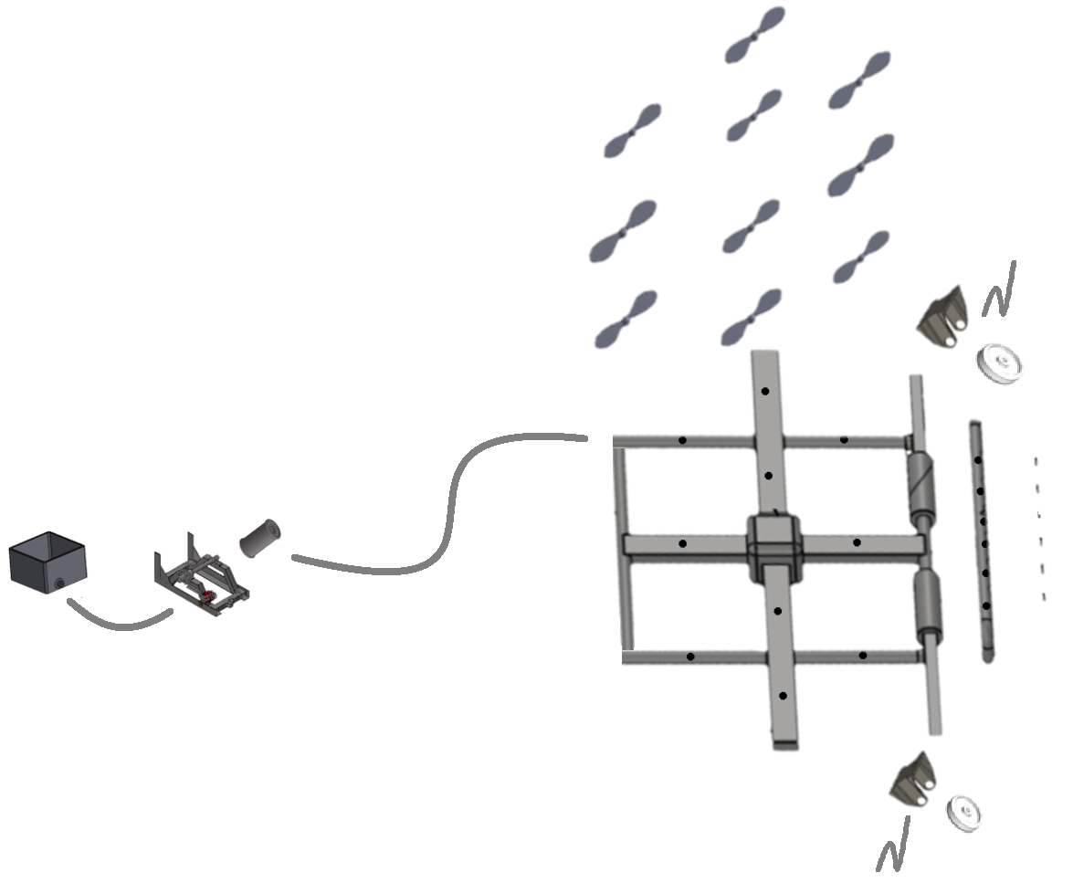

Figure 44: Redesign Assembly

By performing DFMA, we have able to make 80% improvement in the design as the time of assembly reduced to 0.3 hours from 1.5 hours, and number of different parts have reduced by 84%, where originally the different parts are 26, and in re-design the different parts are 4 only, while the cost has reduced from $902 to $780 after the parts have reduced so this improvement is around 13.5%, and the labor cost also reduces by 17.5%. So, the DFMA has improved the design with minimum number of parts and reduced the price as well.

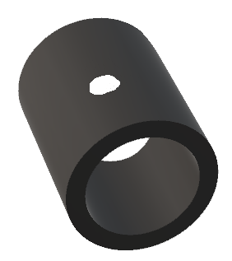 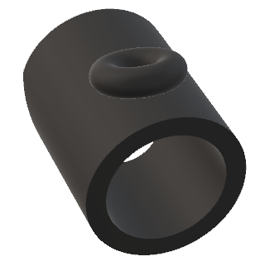

Figure 45: Pipe Old Deign and Redesign

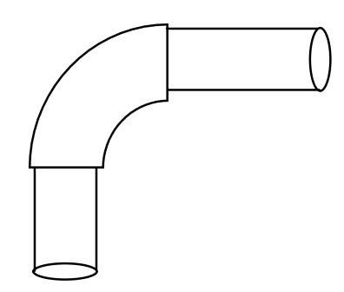 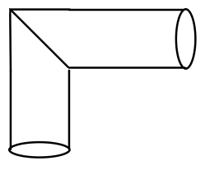

Figure 46: Pipe Connection Old Design and Redesign

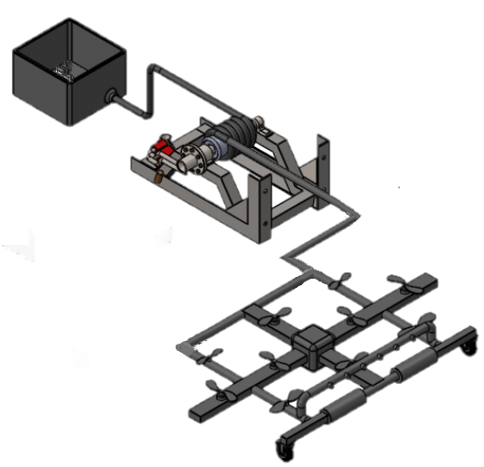

Figure 47: Redesign

Table 9: DFMA Changes and Improvements

|  |  |  |  |
| --- | --- | --- | --- |
| **Description** | **Original Design** | **Redesign** | **Improvements %** |
| Assembly Time Hours | 1.5 | 0.3 | 80 |
| No. of Different Parts | 26 | 4 | 84.62 |
| Total No. of Parts | 56 | 32 | 42.8 |
| Cost | $902 | 780 | 13.5% |
| Labor Cost | $200 | $165 | 17.5% |

Hence the improved design is less in cost and take less time to manufacture as well.

# 7 RISK ANALYSIS AND MITIGATION

The team has mitigated the failures with the high level of testing and confirmed that each part is working and no issue is present in any of the part.

## 7.1 Potential Failures Identified

This section is talking about the risks that are possible to come up during the working of device and it will define the FMEA table to describe the possible failures which can appear in the device and in the mitigation it will define the methods to overcome the risks and the failures to make the device reliable and risk free. The FMEA in shortened form has presented below:

Table 3: FMEA

|  |  |  |  |  |  |  |  |  |  |
| --- | --- | --- | --- | --- | --- | --- | --- | --- | --- |
| **Part # and Functions** | **Potential Failure Mode** | **Potential Effect(s) of Failure** | **Severity (S)** | **Potential Causes and Mechanisms of Failure** | **Occurrence (O)** | **Current Design Controls Test** | **Detection (D)** | **RPN** | **Recommended Action** |
| **1 Controller** |  |  |  |  |  |  |  |  |  |
| 1.1 Controller Brun | Burning of Controller | Disconnection with Drone | 7 | 1. Bad quality of controller | 4 | 1. Over Voltage Test | 4 | 112 | Check the quality of controller |
| 1.4 Controller Body | Breaking of Body | Cracks and bends | 4 | 1. Bad quality of controller | 3 | 1. Over Pressure Test | 3 | 36 | Check the quality of controller |
| 2.2 Motor Widing | Winding burn out | Cost increase | 8 | 1. bad quality of copper 2. poor windings 3. over voltage, over speed | 4 | 1. Speed test 2. Over voltage test | 5 | 160 | Check multiple motors and test |
| 2.4 Motor Wire | Wire Bunr out | Cost increase | 6 | 1. bad quality of copper 2. poor windings 3. over voltage, over speed | 4 | 1. Speed test 2. Over voltage test | 4 | 96 | Check multiple wires |
| 2.9 Motor Insulation | Buring of Insulation | Trouble in running the motor | 4 | 1. Bad quality of plastic insulator | 5 | 1. Over Voltage Test | 4 | 80 | Check the quality of Insulator |
| 3.1 Arduino Board | Burning of board | shorting of circuit | 5 | 1. unsecure circuit lining | 7 | 1. Over Voltage Test | 5 | 175 | Check the circuit lining |
| 3.2 Arduino Pins | Breaking of Pins | Over Pressure | 5 | 1. Pins not inserted Correctly | 7 | 1. Over Pressure Test | 4 | 140 | Check the pins |
| 3.4 Arduino Connections | Failed to connect | Code Issue | 6 | 1. code fixing | 7 | 1. Code fixing problem | 4 | 168 | Check the code resetting |
| 4.3 Battery | Burning of battery | Over Voltage | 5 | Bad quality of battery cells | 5 | 1. Over Voltage Test | 5 | 125 | Check battery quality |
| 4.8 Battery Low output | Less voltage apperas at the output | Cells burning | 5 | Bad qulaiy of cells | 4 | 1. Over Voltage Test | 4 | 80 | Battery check quality |

### 7.1.1 Potential Critical Failure 1: Motor winding burning

The motor winding can fail at any time because motor winding can burn by the over voltage, or over current pass through the winding which means the winding brunt out because of high voltage and if the motor winding will burn out, then the motor will not work and if any single motor will burn out the device will not work as the drone will not even lift if a single motor is not working. Hence the failure has great effect over the device and it need to settle down quickly. This failure can mitigate by using the proper controlled voltage and the voltage must not cross the limits to avoid any kind of winding burning.

### 7.1.2 Potential Critical Failure 2: Motor insulation burning

Another failure which may appear is the burning of insulation which also happens when over voltage pass through the winding and in the case if the winding does not burn, still the winding goes so hot that it burns the insulation and because of the burning of insulation it causes short circuit and it will further burn the winding and other systems in the motor. If the insulation will burn, winding will burn as well and the motor will not start hence the device will no more operational. To mitigate this failure, use the protective ways to control the voltage so that over voltage will not appear.

### 7.1.3 Potential Critical Failure 3: Motor wire

Another failure is the burning of motor wire which is connecting the motor with the supply and this can burn because of over voltage issue therefore it will cause the tripping and it will not let the motor run as the breakage of connection will happen and hence the device will not work. To mitigate this issue again use the voltage with protective ways.

### 7.1.4 Potential Critical Failure 4: Arduino Board

The failure of Arduino board can happen because of shortage of lining of circuit and this is because of any external wire make the connection between the circuits to cause short circuit and this failure will also stop the device because drone can fly but the Arduino is not working which will pass the instruction to fly the drone and perform the operation. To mitigate this failure, protect the Arduino board properly with the insulator and avoid any open wire connection near the Arduino board.

### 7.1.5 Potential Critical Failure 5: Arduino Pins

In this failure the pins of the Arduino board can get damage while connecting with the other products and in that situation that specific component will not be working because of breaking of pin. And in this way the device will not be useful if the important pin will break because it will not let the components working properly. To mitigate this failure, use the device with precautionary measures and use the device with more care.

### 7.1.6 Potential Critical Failure 6: Arduino Connection

This could be common failure of using the Arduino with the other interfacing units including the computer and drone, the failure is that Arduino is not connecting with the drone and the reason could be the Arduino reset option or Arduino did not remove the old complied code after reset which may cause this trouble and the effect is that project will not be in working in that situation because without the working of Arduino the project cannot work. To mitigate this problem, properly start the Arduino and wait for few seconds after start to get the Arduino initialized properly and then connect it with the other interfaces and operate it.

### 7.1.7 Potential Critical Failure 6: Battery Burning

This failure is also possible that battery burns out because of the reason that over voltage have caused the battery to burn out while charging, hence in that case the device will not be working because battery is providing the power and when the battery is dead. In order to mitigate this failure, the charging of the battery has to done with the protective layers using fuse and breakers, if any overcharging pulse comes, the breaker will break the connection.

### 7.1.8 Potential Critical Failure 7: Battery Low Voltage

This is the failure of battery cells which provide low voltage at the output and because of low voltage the system cannot run as the voltage are not enough. This is the case when the battery cells becomes weak or suddenly few cells stops working. In this case again the device will not work, because it will not get required voltages to operate the device. Hence to mitigate this issue, check for the battery voltage at the input which can cause the burning of cells, using the breakers it is possible and if the cells are down and output voltage is low then replace the battery instantly.

### 7.1.9 Potential Critical Failure 7: Controller Burning

Another failure is the burning of remote controller which is controlling the drone. This controller can burn because of many options like short circuit, over voltage and over current. This failure will also stop the working of device because the device will not control as the controller is not able to send any instructions. To mitigate this problem the controller, need to be safely used and use the batteries properly which does not have any kind of over voltage or over current issues.

### 7.1.10 Potential Critical Failure 7: Controller Body Breaking

As a controller is a small device and it can fell down by slipping from hand, and in that case the controller can break like its outer body get break or cracks, in that case a high probability is present that device can work because if the buttons and battery are still intact in the controller, it can control the device and send the instructions to fly the drone and perform the required operation. To mitigate the failure, it is important to protect the controller with extra covering which will not let the controller broke.

## 7.2 Risk and Trade-offs Analysis

Most of the potential failures have defined in the previous section and talking about the failures correlation with each other it can see that most of the failures are interlinking with each other like the motor winding can burn because of over voltage issue, in the same way insulation can burn because of over voltage issue and because of insulation burning, motor winding burn is also possible. Hence mitigating the over voltage issue for the motor will save most of the failures, instead of effecting the other failures so motor issues are relating with the over voltage and using the protective gears will helpful in saving the motor failures. Looking at the Arduino issues failures, Arduino failures are also interlinking with each other and mitigating one failure is not affecting the other issue. As the protective layer use for the Arduino to keep it safe from short circuit will not cause any trouble to other failures. The protective layer may cause a little trouble for the Arduino pins to connect but once it has done it will not need to do again so use the protection of Arduino board after connecting the device components with the Arduino. And the Arduino connection failure mitigation is not affecting the others, as it will start the device and will hold for few seconds to wait and this is not a problem for others.

The potential failure of battery is also relating to the over voltage, so using the breakers for charging the batteries will mitigate many failures and also it will not affect any other failure. As the low voltage failure and burning of battery both are the results of over voltage. Hence using the breakers to avoid the over voltage will not affecting any other failure.

The use of Arduino controller and mitigate to its failures are not affecting the other failures, for example burning of controller is also possible because of over voltage or short circuit and hence mitigating this issue by using extra care will not cause trouble to any other failure. In the same way, using the controller with protective layer is not causing trouble to any other failure. Hence it can state that most of the mitigation for the failures are not affecting the other failures instead mitigation of one failure is also mitigating the other failure.

8 ER PROOFS

The engineering requirements have devised at the start of project and these requirements have devised from the customer requirement. Engineering requirement contained the technical values with the tolerances. The reason for using the engineering requirement is that it can actually calculate from the design and verify that the design has met all the requirements of project. If the engineering cannot meet the requirements the design will not consider a successful project. Therefore, after the completion of project it is necessary to calculate how each engineering requirement has met by the design and it has calculated in this section.

8.1 ER Proof #1 - Flight Time – 20 minutes

The propellers using in the drone are high torque and high-speed motors providing high initial velocity

$$Flight time=\frac{initial velocity *\sin{θ}}{g}$$

$$Flight time=\frac{200 *\sin\left(90\right)}{9.81}$$

$$Flight time=20.38 minutes$$

8.2 ER Proof #2 - Height of Flight – 100 feet

Even though we need the maximum height of 70 feet

$$Height=H=\frac{v^{2}}{2g}$$

$$H=\frac{{25}^{2}}{2*9.81}$$

$$H=31.25 meter=102.5 feet$$

8.3 ER Proof #3 - Water Tank Capacity – 20 liters

$$Volume=Length *Height *Width$$

$$Volume=12 *12*12$$

$$Volume=1728 in^{3}$$

$$Volume=1 ft^{3}$$

$$Volume=28.3 liters$$

8.4 ER Proof #4 - Device Weight – 30 lb.

$$Device Weight=pipes weight+motors+nozzles+propellers+misc$$

$$Device Weight=11+7+3+7+2$$

$$Device Weight=30 lb$$

8.5 ER Proof #5 - Reliable in Temperature – -10C to 40C

In order to check if this requirement has met or not, it has identified from the sources the physical properties of ABS plastic and it has found that:

* + ABS plastic can withstand up-to 60C easily
  + Motors can withstand up-to 65C easily
  + Arduino Controller can withstand up-to 60C easily

8.6 ER Proof #6 - Durable – 2200 MPa

For the physical properties of ABS plastic found:

* + ABS plastic has young's modulus of 2.4 GPa
  + Project need 2200 MPa, where

$$Young^{'}s Modulus=2200 MPa$$

$$Young^{'}s Modulus=\frac{2200}{1000}GPa$$

$$Young^{'}s Modulus=2.2 GPa$$

8.7 ER Proof #7 - Long Power Backup – 30 mints

$$Current=100 mAh$$

$$Time=\frac{Current hours}{current}=\frac{100Ah}{14 A }$$

$$Time=420 hours=2500 minutes$$

8.8 ER Proof #8 - Failsafe Rotation Speed – 25 rpm

$$v=\sqrt{2*d*g}$$

$$falling velocity=v=17.2919\frac{m}{s}$$

$$ω=\frac{v}{r}$$

$$motor rotation=ω=172.92 rpm$$

The motor connected with the reel will rotate more than 25 rpm as it is ¼ hp 12 V dc motor with the RPM of 2600

8.9 ER Proof #9 – Hose Height – 65 feet

One propeller can produce the lifting capacity as

$$v_{a}=140 knots$$

$$v_{a}=72.022\frac{m}{s}$$

$$v_{e}=233 knots$$

$$v_{e}=119.866\frac{m}{s}$$

The formula to calculate the generated thrust from one propeller is

$$F=Density*Area*\left(v_{e}^{2}-\frac{v_{e}v_{a}}{2}\right)$$

And the air density is

$$Density of Air=1.225\frac{kg}{m^{3}}$$

So, the area is

$$Area=0.0052 m^{2}$$

And the force is

$$F=1.225*0.0052*\left({119.866}^{2}-119.866*72.022\right)$$

$$F=36.5311N$$

Hence the total 10 propellers can produce the thrust force of

$$F=10*36.5311$$

$$F=360.5311 N$$

Hence these 10 propellers can generate the thrust of 360.5 N. Now determine the total weight that can lift by the propellers

$$F=W=mg$$

$$m=\frac{F}{g}$$

$$m=\frac{360.5311}{9.81}$$

$$m=37.2386 kg$$

Now convert the mass into pound.

$$m=37.2386*2.20462$$

$$m=82.097 lb$$

Now calculate the weight of hose, the best hose to use is vinyl pipe because of its lightweight option. The weight of vinyl hose is

$$vinyl hose weight=20\frac{lb}{100 feet}$$

The above weight is for the ½ inch diameter pipe and hence the weight of 65 feet long vinyl hose is

$$vinyl hose 65 feet weight=\frac{20}{100}*65$$

$$hose 65 wegith=13 lb.$$

And when the water will present in the pipe, the amount of water in cubic inches are

$$volume=π*r^{2}*hose length$$

$$volume=π*{\left(\frac{0.5}{2}\right)}^{2}*\left(65*12\right)$$

$$volume=306.3053 in^{3}$$

Convert the cubic inch water into liters and that will be equal to same amount of kg as well.

$$volume= 5.1 liters$$

$$volume=5.1*2.2 lb$$

$$volume in lb=11.22 lb$$

Hence the total volume of hose along with the water present in it is

$$total weight=11.22 +13$$

$$total weight=24.22 lb$$

So, the total weight of device that need to be in the air is

$$drone weight=30 lb$$

$$hose weight=24.22 lb$$

$$Total Weight of System=30+24.22$$

$$Total Weigth of System=54.22 lb$$

Hence the total weight lift by the propeller is 82 lb., and the total weight actually is 55 lb. so it can easily lift up the hose and the drone.

# 9 LOOKING FORWARD

In this section the client will provide help with about how he can perform any sort of testing and how can the device be improving if need any improvement.

## 9.1 Future Test Procedures

In this section testing procedures will provide to perform the testing for the future.

### 9.1.1 Testing Procedure 1: Flight Time

Flight time is an important engineering requirement for this project because it will be the time taken by the drone to fly in the air and hence better the flight time will provide more options to clean the signs and can better clean the signs boards.

#### 9.1.1.1 Testing Procedure 1: Objective

The purpose of performing this testing procedure is to find the time of drone it keeps in the air, flight time means the time it will stay in the air to do the cleaning and it is important to find this time because it will help in better cleaning. The required time will start from the fully charged drone to the discharge time. It has required that the flight time will be around 20 minutes, so the drone need to fly for more than 20 minutes in order to fulfill this engineering requirement.

#### 9.1.1.2 Testing Procedure 1: Resources Required

The resources required to test the flight time consist of stopwatch, the stopwatch will use to find the time of drone kept in the air while the drone will fully charge and discharge during the flying. This resource is available in the mobile phone and it is also available in the labs as well so the team will use the mobile phone stopwatch app to measure the flight time of the drone.

#### 9.1.1.3 Testing Procedure 1: Schedule

This testing will schedule in the July, when the project will be ready. Probably it will perform between July 15 to July 20, 2020 and it will perform in the afternoon. This test will take around half an hour and during this testing, some other tests will also perform.

### 9.1.2 Testing Procedure 2: Height of Flight

Height of flight is the peak height of drone form the ground and it is an engineering requirement which will test to see if the requirement has achieved or not. The requirement is to have the height of 20 feet so the test will determine if the drone can above 20 feet or not.

#### 9.1.2.1 Testing Procedure 2: Objective

The objective of performing this test is to see if the engineering requirement has fulfilled by the product or not and to do so the height of flight will measure for the drone using the GPS or barometer. That already installs over the drone.

#### 9.1.2.2 Testing Procedure 2: Resources Required

For finding the height of any object flying above from the ground, we need the GPS system or the barometer, both of these components can give the height of the object form the ground. GPS uses different methodology which is finding the object position from the satellite and then calculate the distance between the grounds and object to give the height of object while the barometer uses the concept of rays to detect the height of object from the ground. Another option to detect the height is to fly the drone along a long pole and determine the height through that pole by taking the pole as relative positioning of drone. In this test, we will use the pole to determine the height of drone and will compare that height with the barometer and GPS installed in the drone. In this way, height will verify from three methods. The pole method can use in our project for testing because we need the drone to fly at a limited height, the height requirement is around 20 feet, so we need the pole of 25 feet to see whether the drone can easily reach to 25 feet or not. And hence 25 feet long pole are easily available in the premises of university therefore this test can perform in the premises of university.

#### 9.1.2.3 Testing Procedure 2: Schedule

This test can perform at any time in the daylight without taking any precautionary measures or take any initial steps.

### 9.1.3 Testing Procedure 3: Water Tank

The water tank is one of the important part of project and it will store the water to clean the sign boards, hence the water tank capacity is important factor in this case so it will test to see how much water tank can store the water in short it will determine the capacity of water tank that will attach to the drone. The required amount of water to store in the tank is 3 liters, so it will see if 3 liters can easily store in the tank or not.

#### 9.1.3.1 Testing Procedure 3: Objective

The objective of performing this test is to find the capacity of water present in the water tank and determine that capacity, if the capacity is not enough the project is not useful for cleaning the sign boards, so the required amount is 3 liters and the water tank will contain more than 3 liter of water and it will test by finding the capacity of tank using the volume of water tank. Which can test by measuring the length, width and height of the tank.

#### 9.1.3.2 Testing Procedure 3: Resources Required

The resources required to perform this test is only a small scale in inches, the scale should be of 12 inches maximum or even 6-inch scale is enough to perform this test. This scale is available in the labs as well as the team contain this scale so it will not need anything else to perform this test. To perform the, use the scale, measure the outer sides of tank, length, width and height and then multiply these three values to find the volume of the tank.

$$Volume=Lenght*Widht*Height$$

The returned volume will be cubic inches then it will convert into liters as

$$1 inches^{3}= 0.0163871 lilters$$

$$Volume (liters)=\frac{Volume (inches^{3})}{61.024}$$

Hence it will give the liters, the volume of water that reach to 3 liters is 200 cubic inches.

$$Volume=200 inch$$

$$Volume=3.27741 liters$$

Hence the water storage tank must be larger than 200 cubic inches

#### 9.1.3.3 Testing Procedure 3: Schedule

This test can perform at any time in the daylight without taking any precautionary measures or take any initial steps.

### 9.1.4 Testing Procedure 4: Device Weight

Weight of the device is another important factor in the device and it is also one of the important engineering requirement that must need to fulfill because the weight plays major role, if the weight is too much it will be difficult for the drone to carry lot of weight, as the water stand, water tank, and water will also include in the weight so measuring the weight is quite necessary for the product and the required weight is 2 kg maximum without the water.

#### 9.1.4.1 Testing Procedure 4: Objective

The main objective of performing this test is to analyze the total weight of device including the water shower, tanks etc. This is important to find because a limited amount of weight can lift by drone and if the weight will increase, the lifting capacity need to increase for the drone which will increase the cost of product as it will use more powerful motors.

### 9.1.4.2 Testing Procedure 4: Resources Required

The resource required to perform this test is weight machine, which is easily available in the labs, mechanical lab has the weight machine so the team will use the machine from the lab and it will measure the weight. The device will take to the lab and after resetting the weight machine, and then place the final product on it. It will perform without any high-pressure air passing around because it can tilt the device and the weight result will not be correct in that case.

#### 9.1.4.3 Testing Procedure 4: Schedule

This test can perform at any time in the daylight without taking any precautionary measures or take any initial steps.

### 9.1.5 Testing Procedure 5: Reliable in Temperature

The device will use on the roads in the open atmosphere so it is important that it must be resistant to different temperatures like in high temperatures and in low temperatures it will not face any trouble while working. This is an engineering requirement and it states that the device needs to work in between -10 degrees to 40 degrees. This test can perform by placing the device in a cold storage environment to test the lowest temperatures and for highest temperatures it can place in the heated room where the temperature can raise to 40 degrees.

#### 9.1.5.1 Testing Procedure 5: Objective

The objective of this test is to find that the device is resistant to high and low temperatures because it will work in the open atmosphere and the temperature can be too high or too low in some conditions so the device will not face any trouble during the working because of the temperature. The range required is from -10 degrees to 40 degrees, the device must perform above these temperatures as well. And this test can perform by placing all the components in the refrigerator and in the hot room.

#### 9.1.5.2 Testing Procedure 5: Resources Required

The components required to perform this test are two, basically to test the device between the lowest temperatures, considering that the lowest temperatures ranges from -10 degrees to 5 degrees, while the highest temperatures ranges from 30 degrees to 40 degrees. While the middle temperature range can test in the room with room temperature. For the lowest temperature put the device in the refrigerator and set the temperatures to the lowest values but the problem here is to placing the device in the refrigerator because refrigerator is too small to put such device in that case we can put all the components from wires, to boards, to motors, to structural parts in the refrigerator before assembling, and then test the device, while perform the same actions in the highest temperatures. It would be better to perform this test before assembling the parts because it will not take more space and the test can perform easily.

#### 9.1.5.3 Testing Procedure 5: Schedule

This test can perform at any time in the daylight without taking any precautionary measures or take any initial steps.

### 9.1.6 Testing Procedure 6: Durable

The durability of any project tell the life span of that device and it also tells the reliability of product. The durability test can perform by testing the characteristics of system functions and see how the systems have performed under specific conditions to declare it durable.

#### 9.1.6.1 Testing Procedure 6: Objective

The objective of this test is to determine the durability of system, and durability means how much the device is durable and how long the life span of device is. For measuring the durability of device, it has tested already under the critical temperatures in the earlier stage of assembling, while the performance of device has not tested in those temperatures, so it will test after the device will manufacture and it will perform under possible critical temperatures achievable in the room. Furthermore, it will test for failsafe, a condition in which the device will stop performing suddenly and can drop down from the height so that test will also perform to declare the durability of device and in case of malfunctioning what will happen to the device will also perform to see the durability of product.

#### 9.1.6.1 Testing Procedure 6: Resources Required

The required resources for performing this test consist of temperature conditions, which can attain in the room using the AC and heater which can change the temperatures instantly. The failsafe test can perform in the room as well as outside, and check what will happen to the device if it will fall. For failsafe, turn off the Arduino power suddenly while in the flying to see what will happen to it and how the reel will hover the device and keep it safe from falling down. And for malfunctioning of the device, use a random code which will cause the malfunctioning in the device and see how the reel will capture the drone in that case.

#### 9.1.6.3 Schedule

This test can perform at any time in the daylight without taking any precautionary measures or take any initial steps.

### 9.1.7 Testing Procedure 7: Long Power Backup

As the device will get the power from external source so it is clear that it will get the long-term power but in order to test, the team will need the timer and see if the power is providing consistently for 30 minutes or getting any kind of interruption in it. Through the timer it will simply test.

#### 9.1.7.1 Testing Procedure 7: Objective

The objective is to see if the power is providing for consistently or any interruption is present. So that it can resolve and the drone will not face any problem in getting the power.

#### 9.1.7.2 Testing Procedure 7: Resources Required

It will need the timer which is available in the cell phone so use the cell phone and set the timer to count the time for providing the power.

#### 9.1.7.3 Testing Procedure 7: Schedule

This test can perform at any time in the daylight without taking any precautionary measures or take any initial steps.

### 9.1.8 Testing Procedure 8: Failsafe Rotation Speed

This is the speed of reel that will provide the safety to the drone. When the done will fail, the reel will rotate fast and catch the drone to bring it down on the ground safely before it hits the ground because of gravity.

#### 9.1.8.1 Testing Procedure 8: Objective

The objective is to provide the safety to the device if it fails to operate in the air.

#### 9.1.8.1 Testing Procedure 8: Resources Required

For the resources, it needs the tachometer to check the speed of motor, the rotation of speed will count by the tachometer and that will be more than 25 rpm.

#### 9.1.8.3 Schedule

This test can perform at any time in the daylight without taking any precautionary measures or take any initial steps.

### 9.1.9 Testing Procedure 9: Hose Height

This is the height of hose to see how high the drone will fly. The hose is connecting between the drone and the reel.

#### 9.1.9.1 Testing Procedure 9: Objective

The objective is to test the length of hose and it has be 65 feet at least.

#### 9.1.9.1 Testing Procedure 9: Resources Required

For this testing, it will need the feet scale to measure the length of hose.

#### 9.1.9.3 Schedule

This test can perform at any time in the daylight without taking any precautionary measures or take any initial steps.

## 9.2 Future Work

In future the device design can improve further and the improvement can be made in the context of increase in power capacity will increase the loading capacity of drone to lift up in the air. For the improvement in design, we will make it autonomous so that it can do the task automatically. Like it will detect the sign bord automatically through the improved design, and it will clean that board automatically without using the remote. The water will re-fil in the tank automatically and nozzles will operate automatically. Hence the system will become fully automatic with the improvements we want to do in the design in future. These improvements can be made easily in the design with some additional components and install these components to get the device ready to use.

The testing procedure will help in improving the design as these tests will perform on the device after the improvement and will see if the design has improved from the previous testing, the results have changed any modifications in the results have seen while testing.

10 CONCLUSIONS

The project goal was to design a device that will clean the traffic sign boards, and without interrupting the traffic flow. The device has designed properly that fulfilled the goals and requirements of the project.

10.1 Contributors to Project Success

The project has successfully completed with the efforts of all team members. The team has done well and the support of instructor and client played a major role as well in completing the project successfully. The project was to develop any traffic sign board cleaner and the team has designed a drone system that will fly in the air and without interrupting any traffic it will clean the traffic board, hence the main important customer requirement was no disturbance in traffic flow will occur by the use of this system and this engineering requirement has fulfilled. It is clear that the main purpose of the project is to design a system that will clean the traffic sign boards without interrupting the traffic flow and the team developed the design of a system that can clean the traffic sign boards and no traffic flow affect from it. Hence the purpose mentioned in the team charter has completed by the team in this project.

Our team goal is to make a device that can clean traffic signs in the highways by itself without making the people in the highways stop. The main purpose is clean the dust and dirt in the signs so people can see it clearly and will know where to go. For example, Los Angeles, California they always have traffic in their highways and sometimes the signs get dust so they won’t see anything while they driving. The people who work for cleaning the signs have to find a good time to clean the signs without any traffic, so that device that we going to make, it is going to make it easier to do the work without stopping the traffic.

On the other hand, we have to look more about the safety because it is so important to our project. For example, if the device falls down in the traffic in the highway it will be danger and it may make damage for some people by hitting their cars. Furthermore, we have to focus about the water for cleaning the signs to make it small drips so it won’t affect the drivers while they driving.

The goals mentioned in the team charter have completed in the project by designing a system to clean the traffic sign boards and, in the design, it has the fail-safe option as well in order to provide safety to the system in case it fails to operate. So, it can state that both the purpose and goals stated in the team charter have completed by the project. The goal of cleaning the dust on the traffic sign boards can clean with the proposed design hence the contribution towards the success has made in the project through the designing of such a unique idea of cleaning in the air.

The ground rules mentioned in the team charter have followed properly during the project. Here are the ground rules mentioned in the team charter.

**Data Sharing:** We are going to create/share a google drive accessible by all members to view the completed tasks and each one in the group can update it.

**Time Management:** Any members who is late more than ten minutes, gets coffee or pizza for everyone in the group. Also, if you miss two meetings this will affect your peer evaluation for everyone in team members. Being lazy and missing your parts which might affect the group grades will be reflected your peer evaluation as well.

The coping strategies mentioned in the team charter have used in capstone project. Hence following the coping strategies helped out in completing the tasks successfully. The coping strategy mentioned in the team charter were about the time management, that if anyone will be late will bring something edible hence this coping strategy worked and team members were there in the meeting on time. So, this coping strategy has worked well in the capstone for the ground rules.

The most positive aspect of project performance was time management, and designing of the project. The team has managed the time properly, all the tasks have done earlier then the deadline which makes the project ahead of the schedule. The most negative aspects of the project were generating the conceptual designs, which were not as good as it has to be. Although the team has able to find out the best solution fulfilling the requirements but yet the creative design ideas that have generated were not up to the mark.

Different troubles looked by the group was building up the CAD model as the individuals from group were acceptable in SolidWorks however building up the 3D model was hard for them so CAD model caused the challenges. After that building up the model was another trouble looked by the colleagues in light of the fact that the group didn't know about the material which can use to make the model however it has arranged also and model has manufactured.

The technical lesson learnt in this capstone project is that any design project can only implement when all the documentation for the design process has done properly, without the implementation of documentation it is not possible to design anything which fulfill all the needs of requirements. The documentation like research, literature review, existing designs, conceptual designs generated and selection of final design. All these things are important in any design project and that’s the learning from previous semester.

10.2 Opportunities/Area of Improvement

In every design project there are plenty of areas which can improve with the time, and same is the case with this project. This project can improve as well with the time, like the improvement can make in the design in such a way that it will become fully autonomous design that will not need any human guidance and it will automatically detect the sign board and clean it. For this purpose it need some sensors and image processing techniques need to apply on the controller along with the camera and sensors, that will detect the hurdles and will detect the sign board. And the drone will fly towards the sign board, and clean it, so that no human interaction will involve in it.

Another improvement that can made in it is the loading capacity of drone can increase so that will carry the water in the air as well instead of taking the hose. In this way the automatic features of drone will become more enhance and thus the device will statistically able to work like a complete auto robot. The loading capacity can increase by increasing the propellers thrust and may need to increase the number of propellers as well that will need the advancement in the size of drone as well. The length of propellers can play a major and changing the length of propellers will also increase the thrust that will raise the lifting capacity of the device.

Another improvement that can make in the design is the use nozzles and brush rollers, as currently they are throwing the water from some distance which can further enhance in such a way that any the nozzle will go more closely to the sign board along with the brush and in this the water drops will split on the highway as well and the board can clean easily with the nozzle being closer to the board.

The advantage of using the moveable arm for the nozzle is that it will able to throw the water from different distances and depending on the dirt present on sign board the distance will manage, sometime the dirt is tedious and difficult to remove so moving the nozzles more closer to the bord will increase the pressure of nozzle and it will able to stiff dirt.

Another improvement can made in the pressure of nozzle by controlling the nozzle through the valves and increase or decr3aee the pressure of nozzle through the valve. This advancement will also let the device save more water and perform better by cleaning the board easily and it will reduce the time of cleaning and in short period of time, more boards will clean with this improvement in the design.

These are the few improvement which make in the design in the future and the device will become automatic and efficiency of the system will increase.

# 11 REFERENCES

[1] B. Marian, “Investigation of hydraulic fitting losses”, available [online], <https://www.researchgate.net/publication/325338468_Investigation_of_hydraulic_fitting_losses>

[2] M. Santosh, “Compartive study for Wiper Control System Using MATLAB”, available [online], <https://www.researchgate.net/publication/335524435_Comparative_Study_for_Wiper_Control_Systems_using_MATLAB_Tools>

[3] P. Imade, “Design, Production, and Testing”, available [online], <https://www.researchgate.net/publication/320244094_Design_Production_and_Testing_of_a_Single_Stage_Centrifugal_Pump>

[4] B. Mohammed”, Power Supply Architectures for Drones”, available [online], <https://www.researchgate.net/publication/336669179_Power_Supply_Architectures_for_Drones_-_A_Review>

[5] L. Leo, “Working Principle of Arduino and its tools”, available [online], <https://www.researchgate.net/publication/326316390_WORKING_PRINCIPLE_OF_ARDUINO_AND_USING_IT_AS_A_TOOL_FOR_STUDY_AND_RESEARCH>

[6] T. Ribbon, “Time Management Guide and 11 Effective Ways to do the Time Management”, available [online], https://www.tonyrobbins.com/importance-time-management/time-management-skills/

[7] A. Side, “The Importance of Time Management”, available [online], https://azslide.com/download/the-importance-of-time-management-to-become-efficient-in-the-workplace_5a3d65d31723dd788a842278.html

[8] U. Fyi, “How to Write Effective Post Mortem Report”, available [online], https://usefyi.com/postmortem-report/

[9] B. Marian, “Investigation of hydraulic fitting losses”, available [online], https://www.researchgate.net/publication/325338468_Investigation_of_hydraulic_fitting_losses

[10] M. Santosh, “Compartive study for Wiper Control System Using MATLAB”, available [online], https://www.researchgate.net/publication/335524435_Comparative_Study_for_Wiper_Control_Systems_using_MATLAB_Tools

[11] P. Imade, “Design, Production, and Testing”, available [online], https://www.researchgate.net/publication/320244094_Design_Production_and_Testing_of_a_Single_Stage_Centrifugal_Pump

[12] B. Mohammed”, Power Supply Architectures for Drones”, available [online], https://www.researchgate.net/publication/336669179_Power_Supply_Architectures_for_Drones_-_A_Review

[13] L. Leo, “Working Principle of Arduino and its tools”, available [online], https://www.researchgate.net/publication/326316390_WORKING_PRINCIPLE_OF_ARDUINO_AND_USING_IT_AS_A_TOOL_FOR_STUDY_AND_RESEARCH

[144] D. John, “Traffic Sign Cleaner Visionclean”, available [online], <https://www.r-italia.it/en-us/traffic-sign-cleaner-visionclean/>

[15] BBC, “Clearning Signs Manually”, available [online], <https://www.bbc.com/news/uk-england-nottinghamshire-47668406>

[16] I. Mart, “Solar Cleaning Boards”, available [online], <https://www.indiamart.com/proddetail/automatic-solar-panel-cleaning-14748345333.html>

[17] J. George, “Plastic Propellers”, available [online], <https://www.dreamstime.com/yellow-plastic-propellers-quadcopter-drone-isolated-white-background-image137056235>

[18] F. John, “Aluminum Propellers”, available [online], <https://hartzellprop.com/products/propeller-systems/aluminum-propellers-piston-engine-aircraft/>

[19] G. Man, “Carbon Fiber Propellers”, available [online], <http://www.helipal.com/tarot-1455-carbon-propellers-two-holes-cw-and-ccw.html>

[20] C. Mos, “DC MOTOR”, available [online], <https://circuit.rocks/dc-motor-480-rare-earth.html>

[21] F. Kala, “Stepper Motor”, available [online], <https://www.banggood.com/42mm-12V-Nema-17-Two-Phase-Stepper-Motor-For-3D-Printer-p-1164619.html>

[22] H. Fine, “Servo Motor”, available [online], <https://www.jsumo.com/mg996r-servo-motor-digital>

[23] T. Temo, “Arduino”, available [online], <https://learn.sparkfun.com/tutorials/what-is-an-arduino/all>

[24] R. Bi, “Raspery Bi”, available [online], <https://www.sparkfun.com/products/14643>

[25] T. Roy, “Beagboard”, available [online], <https://w11stop.com/beaglebone-black-wireless>

# 12 APPENDICES

## 12.1 APPENDIX A – DESIGN CALCULATIONS

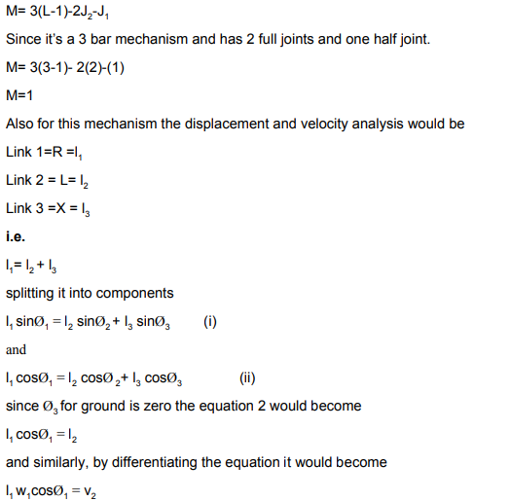

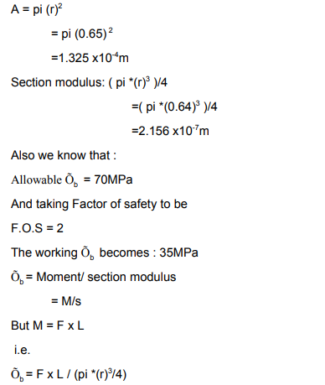

## 12.2 APPENDIX B: Bill of Material (BOM)

|  |  |  |  |  |  |  |  |  |
| --- | --- | --- | --- | --- | --- | --- | --- | --- |
| **Team** | | | |  | | | | |
| **Part #** | **Part Name** | **Qty** | **Description** | **Functions** | **Material** | **Dimensions** | **Cost** | **Link to Cost estimate** |
| 1 | 6 mm Motor | 10 | Rotate the Propellers | Rotate the propellers | Steel | 1.2 x 1 in | $250.72 | Ebay |
| 2 | Steel Sheet | 1 | For Water Tank | Make the Water Tank | Steel | 100 x 100 mm | $38.32 | Ebay |
| 3 | Arduino | 1 | Control the Drone | Pass the signals to each part | Silicon | 4 in x 4 in | $3.49 | Ebay |
| 4 | Controller | 1 | Control the Remotely | Connect with Arduino to pass signals | Plastic | 6 x 4 in | $27.99 | Ebay |
| 5 | Reel Motor | 1 | Rotate the reel | Provide Failsafe operation | Iron Copper | 15 in x 8 in | $78.28 | Ebay |
| 6 | Hose | 1 | Connect with Drone and Reel | Provide Failsafe operation | plastic | 4 x 2 in | $29.50 | Ebay |
| 7 | Screws | 50 | Make the connections | Hold the parts | Steel | 0.5 x 0.1 in | $1.14 | Ebay |
| 8 | Pipe | 8 | Make drone structure | Design the Structure | ABS Plastic | 50 feet | $178.50 | Ebay |
| 9 | Electric Power Wire | 1 | Provide Power | Connect the power with the Arduino | Copper | 10 feet | $11.96 | Ebay |
| 10 | Jumper Wires | 4 | Connect between the parts | Make all the connection for supply | Copper | 6 x 0.1 in | $4.00 | Ebay |
| 11 | Wheels | 2 | To move the device | Assist in moving by reducing friction | Rubber | 6 in | $2.45 | Ebay |
| 12 | Propeller | 10 | Rotate the Propellers | Lift the drone with the propeller | Plastic | 4 in x 2 in | $60.55 | Ebay |
| 13 | Brushes | 2 | Clean the boards | Rotate and clean the water from board | Fabric | 4 in x 2 in | $12.20 | Ebay |
| 14 | Nozzles | 5 | Shower the water | Throw water on the boards | Steel | 3 in | $20.10 | Ebay |
| 15 | Reel | 1 | Rotate quickly | Provide Failsafe operation | Steel | 20 in x 15 in | $50.00 | Ebay |
| 16 | Adhesive lOtion | 2 | Make the connections of structure | fix the pipes and elbows | Chemical | 6 in | $2.44 | Ebay |
| **Total** | | | | | | | $771.64 |  |
| **Total incl. tax** | | | | | | | $902.82 |  |

## 12.3 APPENDIX B – FMEA

|  |  |  |  |  |  |  |  |  |  |
| --- | --- | --- | --- | --- | --- | --- | --- | --- | --- |
| Product Name | | Development Team | | | | Page No of | | | |
| System Name | | FMEA Number | | | |
| Subsystem Name | | Date | | | |
| Component Name |  |  | | | |
| Part # and Functions | Potential Failure Mode | Potential Effect(s) of Failure | Severity (S) | Potential Causes and Mechanisms of Failure | Occurrence (O) | Current Design Controls Test | Detection (D) | RPN | Recommended Action |
| **1 Controller** |  |  |  |  |  |  |  |  |  |
| 1.1 Controller Brun | Burning of Controller | Disconnection with Drone | 7 | 1. Bad quality of controller | 4 | 1. Over Voltage Test | 4 | 112 | Check the quality of controller |
| 1.2 Controller Transmitter | Burning of ransmiter | Disconnection with Drone | 6 | 1. Bad qualit of transmitter | 4 | 1. Over Voltage Test | 4 | 96 | Check the quality of controller |
| 1.3 Controller Reciever | Burning of Reciever | Disconnection with Drone | 6 | 1. Bad quality of reciever | 4 | 1. Over Voltage Test | 4 | 96 | Check the quality of controller |
| 1.4 Controller Body | Breaking of Body | Cracks and bends | 4 | 1. Bad quality of controller | 3 | 1. Over Pressure Test | 3 | 36 | Check the quality of controller |
| 1.5 Controller Board | Burning of board because of short circuit | Disconnection with Drone | 3 | 1. Bad quality of controller | 3 | 1. Over Voltage Test | 3 | 27 | Check the quality of controller |
| 1.6 Controller battery | battery Dead | Disconnection with Drone | 4 | 1. Bad quallity of battery cells | 4 | 1. Over Voltage Test | 4 | 64 | Check the battery qualty |
| 1.7 Controller Button | Button failure | Not working of specific function | 3 | 1. Bad quality of push button | 3 | 1. Over Pressure Test | 4 | 36 | Check the qulaity of button |
| 1.8 Controller Handle | Handle stick motion failure | Not working the directions | 3 | 1. Bad quality of handle | 3 | 1. Over Pressure Test | 3 | 27 | Check the quality of handle |
| 1.9 Controller Screen | Breaking of screen | No display | 3 | 1. Extra presure and bad quality | 3 | 1. Over Pressure Test | 2 | 18 | Protect the screen |
| 1.10 Controller Range | Failure of range abruptly | Low battery level | 3 | 1. Voltage excess and low level | 2 | 1. Over Voltage Test | 3 | 18 | Check the qulaity of battery |
| **2 Motor** |  |  |  |  |  |  |  |  |  |
| 2.1 Shaft | Bending of Shaft, Breakage of Shaft | wait for new shaft, cost increased | 7 | 1.Bad quality due to molding,  2. poor quality shaft is used | 4 | 1.Bad seeding, Poor Quality aluminum | 6 | 168 | Test various qualities if pipes available at same cost |
| 2.2 Motor Widing | Winding burn out | Cost increase | 8 | 1. bad quality of copper 2. poor windings 3. over voltage, over speed | 4 | 1. Speed test 2. Over voltage test | 5 | 160 | Check multiple motors and test them roguishly |
| 2.3 Motor Housing | Bending of Housing | Body trouble will cause extra cost | 2 | 1. Bad qulaty of steel | 3 | 1. Over Pressure Test | 2 | 12 | Check the qulaity of houisng |
| 2.4 Motor Wire | Wire Bunr out | Cost increase | 6 | 1. bad quality of copper 2. poor windings 3. over voltage, over speed | 4 | 1. Speed test 2. Over voltage test | 4 | 96 | Check multiple wires |
| 2.5 Motor Stator | Bending of stator | Cost increase | 2 | 1. Bad quality of steel | 1 | 1. Over Pressure Test | 3 | 6 | Check the qulaity of steel |
| 2.7 Motor Rotor | Bending of rotor | Cost increase | 3 | 1. Bad quality of steel | 1 | 1. Over Pressure Test | 3 | 9 | Check the qulaity of steel |
| 2.8 Motor Bearing | Slip of balls | Cost increase | 4 | 1. bad qulaity of bearing | 3 | 1. Over Pressure Test | 3 | 36 | Check the quality of bearings |
| 2.9 Motor Insulation | Buring of Insulation | Trouble in running the motor | 4 | 1. Bad quality of plastic insulator | 5 | 1. Over Voltage Test | 4 | 80 | Check the qulality of Insulator |
| 2.10 Motor Screws | Detach of screws | Vibrations cause removal of screws | 2 | 1. Bad quality of covering | 4 | 1. Over Pressure Test | 3 | 24 | Check the quailty of screws |
| **3 Arduino** |  |  |  |  |  |  |  | 0 |  |
| 3.1 Arduino Board | Burning of board | shorting of circuit | 5 | 1. unsecure circuit lining | 7 | 1. Over Voltage Test | 5 | 175 | Check the circuit lining |
| 3.2 Arduino Pins | Breaking of Pins | Over Pressure | 5 | 1. Pins not inserted Correctly | 7 | 1. Over Pressure Test | 4 | 140 | Check the pins |
| 3.3 Arduino Components | Breaking of Components | Over Pressure | 5 | 1. components break | 6 | 1. Over Pressure Test | 5 | 150 | Check the components properly |
| 3.4 Arduino Connections | Failed to connect | Code Issue | 6 | 1. code fixing | 7 | 1. Code fixing problem | 4 | 168 | Check the code reseting |
| 3.5 Arduino Reset | Failed to reset the board | Code Issue | 5 | 1. code fixing | 6 | 1. Code fixing problem | 5 | 150 | Check the reseting in the code |
| 3.6 Arduino Reciever | Reciever failed to responsd | Code issue or physical issue | 5 | Reciever not working properly | 5 | Antenna check | 7 | 175 | Reciever Check |
| 3.7 Arduino Transmitter | Failed to send the data | Code issue or physical issue | 5 | Transmittor not workin properly | 5 | Antenna check | 7 | 175 | Transmittor check |
| 3.8 Arduino Power Source | Power source burning | Power source burning | 4 | Burning of source may break | 4 | 1. Over Voltage Test | 6 | 96 | Power source check |
| 3.9 Arduino adoptor | burning of adoptor | Power source burning | 4 | Power adoptor burns | 4 | 1. ove voltage test | 5 | 80 | check the adoptor |
| 3.10 Arduino heat sink | Burning of heat sink | Heat sin cause trouble | 5 | Bad qualiyf of heat sink | 3 | 1. Over Voltage Test | 5 | 75 | check the heat sink quality |
| **4 Batteries** |  |  |  |  |  |  |  | 0 |  |
| 4.1 Over voltage | Producing over voltage caussing other devices to burns | Over Current | 5 | Bad quality of battery cells | 5 | 1. Over Voltage Test | 6 | 150 | Check quality of battery cells |
| 4.2 Over Current | Producing over current | Over Voltage | 5 | Bad qaulty of battery cells | 5 | 1. Over Current Test | 6 | 150 | Check quality of battery cells |
| 4.3 Battery | Burning of battery | Over Voltage | 5 | Bad quality of battery cells | 5 | 1. Over Voltage Test | 5 | 125 | Check battery quality |
| 4.4 Battery Cover | Breaking of cover | Over Pressure | 2 | Bad quality of plastic | 4 | 1. Over Pressure Test | 4 | 32 | Check qualty of cover |
| 4.5 Battery storage | Fail to store | Cells burning | 4 | Bad qulality of cells | 3 | 1 Over Voltage test | 4 | 48 | Storage quality |
| 4.6 Battery Positive Terminal | Breaking of termial | Over Pressure | 3 | bad qualty of terminal | 4 | 1. Over Pressure Test | 4 | 48 | Battery Terminal |
| 4.7 Battery Negative Terminal | Breaking of Terinal | Over Pressure | 3 | Bad quality of terminal | 4 | 1. Over Pressure Test | 4 | 48 | Battery Terminal |
| 4.8 Battery Low output | Less voltage apperas at the output | Cells burning | 5 | Bad qulaiy of cells | 4 | 1. Over Voltage Test | 4 | 80 | Battery check quality |
| 4.9 Battery Swell | Burning of cells | Over Voltage issue | 8 | Time period of battery | 4 | 1. Over Voltage Test | 3 | 96 | check the battery life |
| 4.10 Battery connections | Burning of battery internal connections | Over Voltage issue need to recover | 5 | Bad quallity of cells | 4 | 1. Over Voltage Test | 4 | 80 | Check the battery qualty |